**Data Structures and Algorithms**

[**Mathematics**](https://practice.geeksforgeeks.org/tracks/DSASP-Mathematics/?batchId=154)

Mathematics

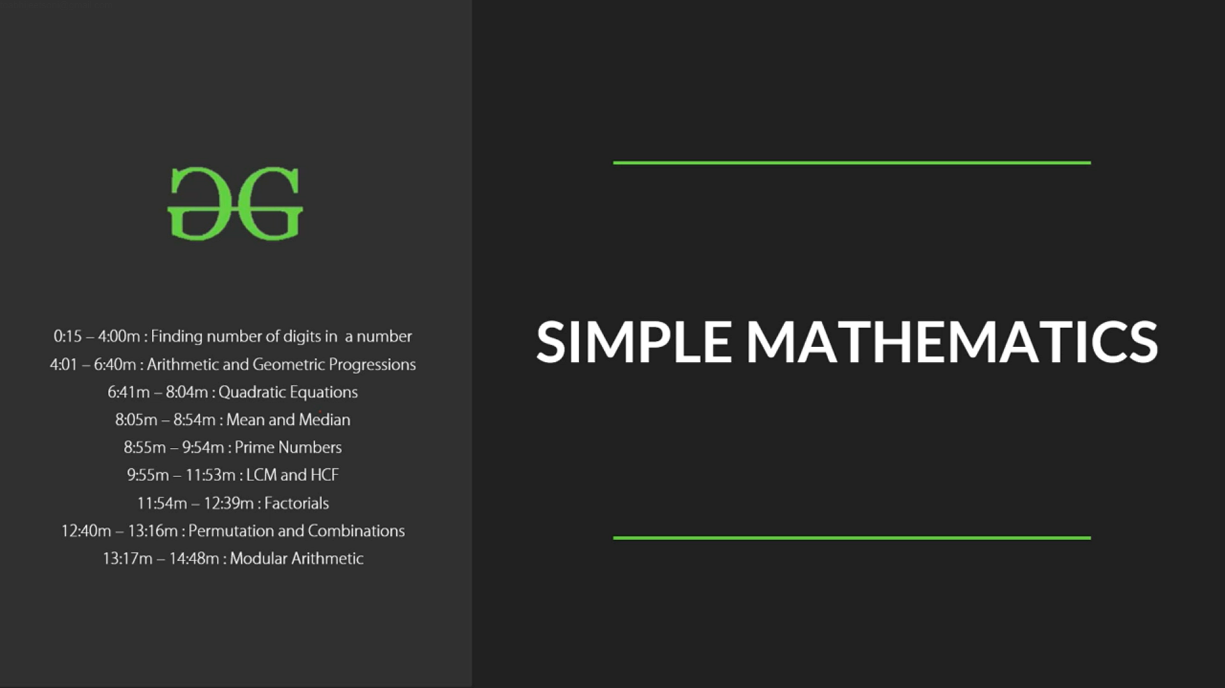

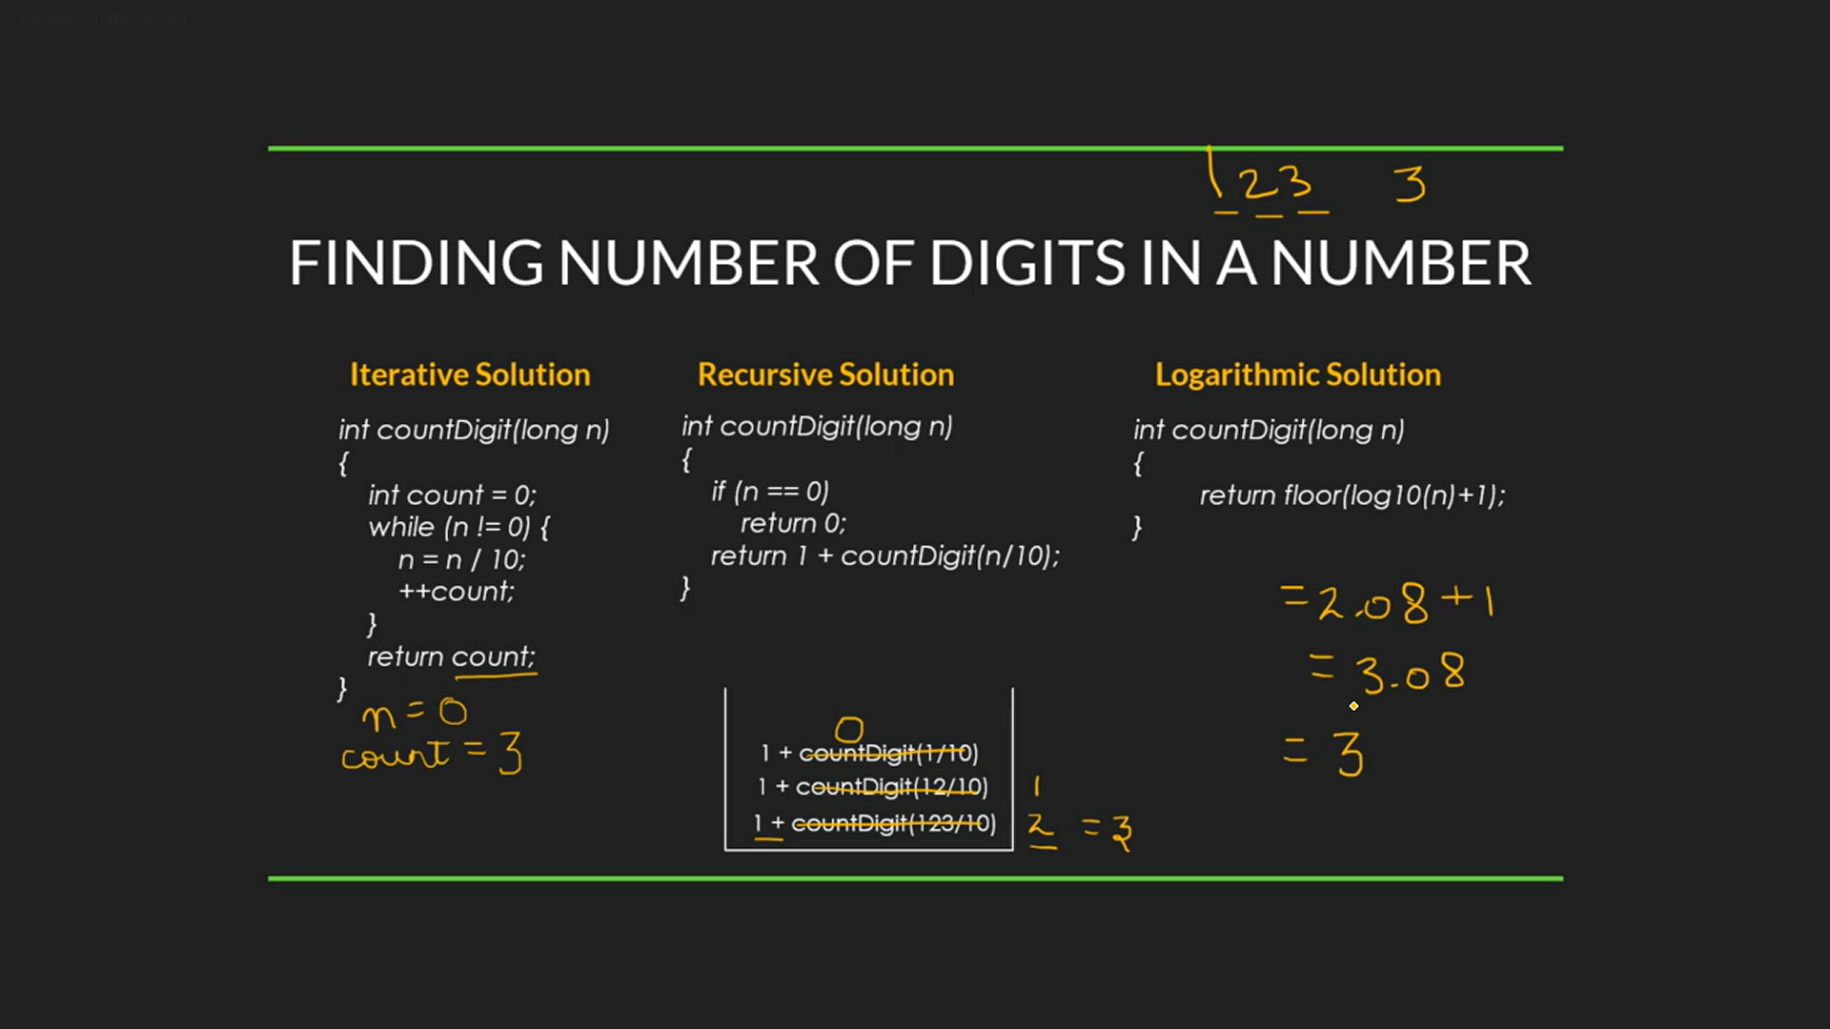

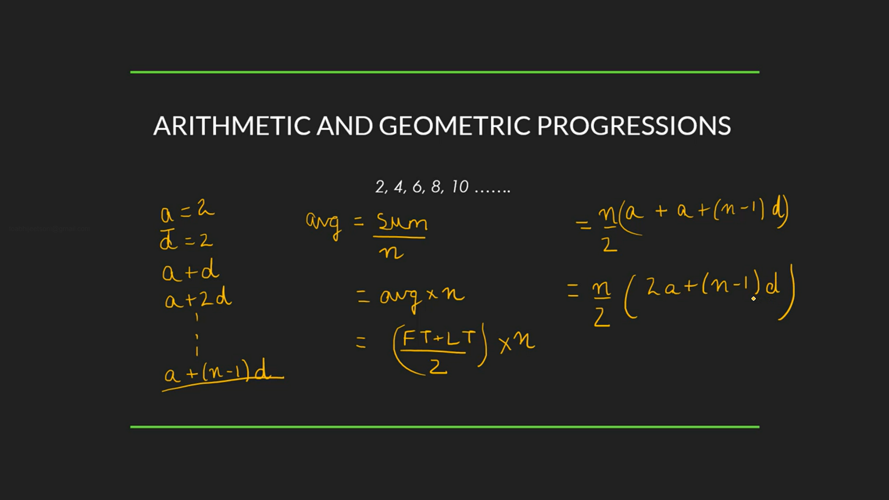

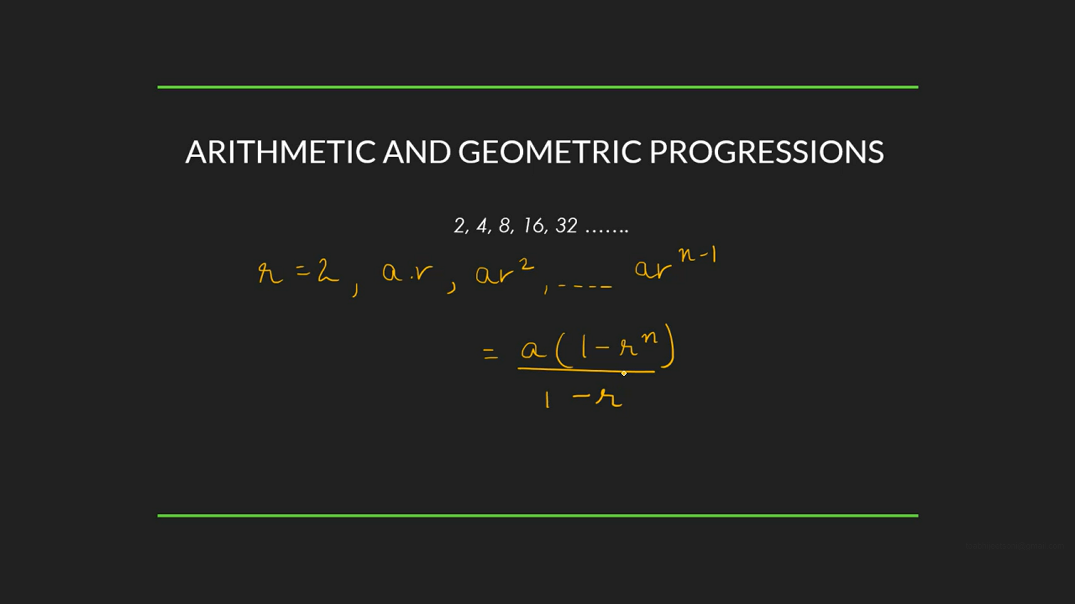

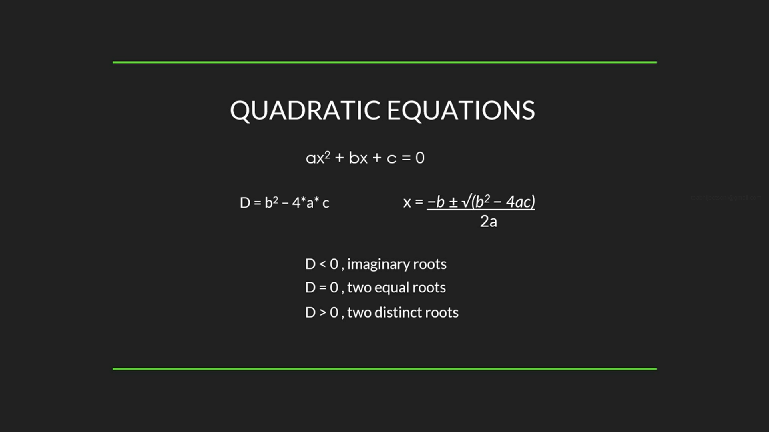

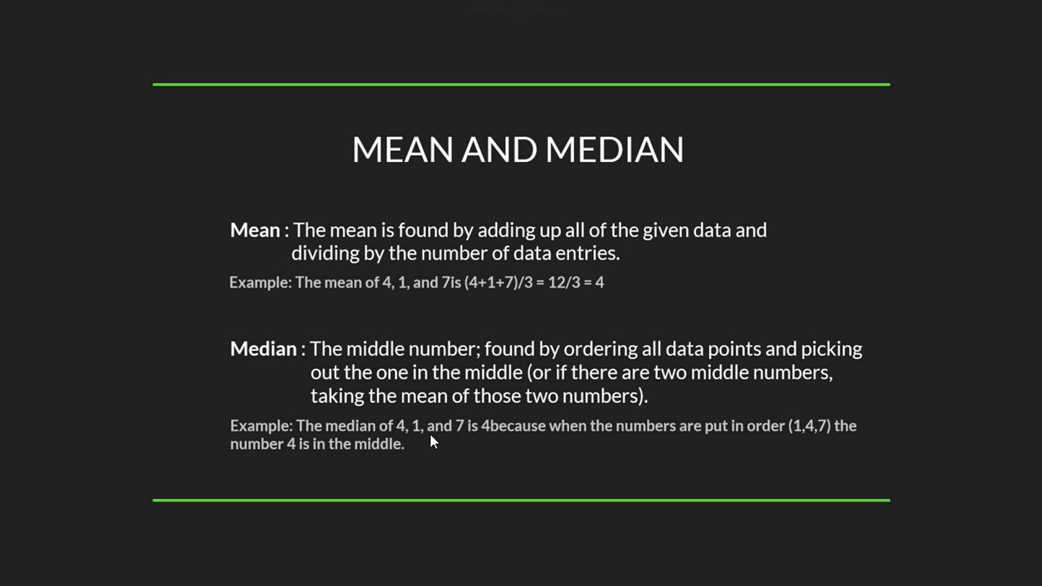

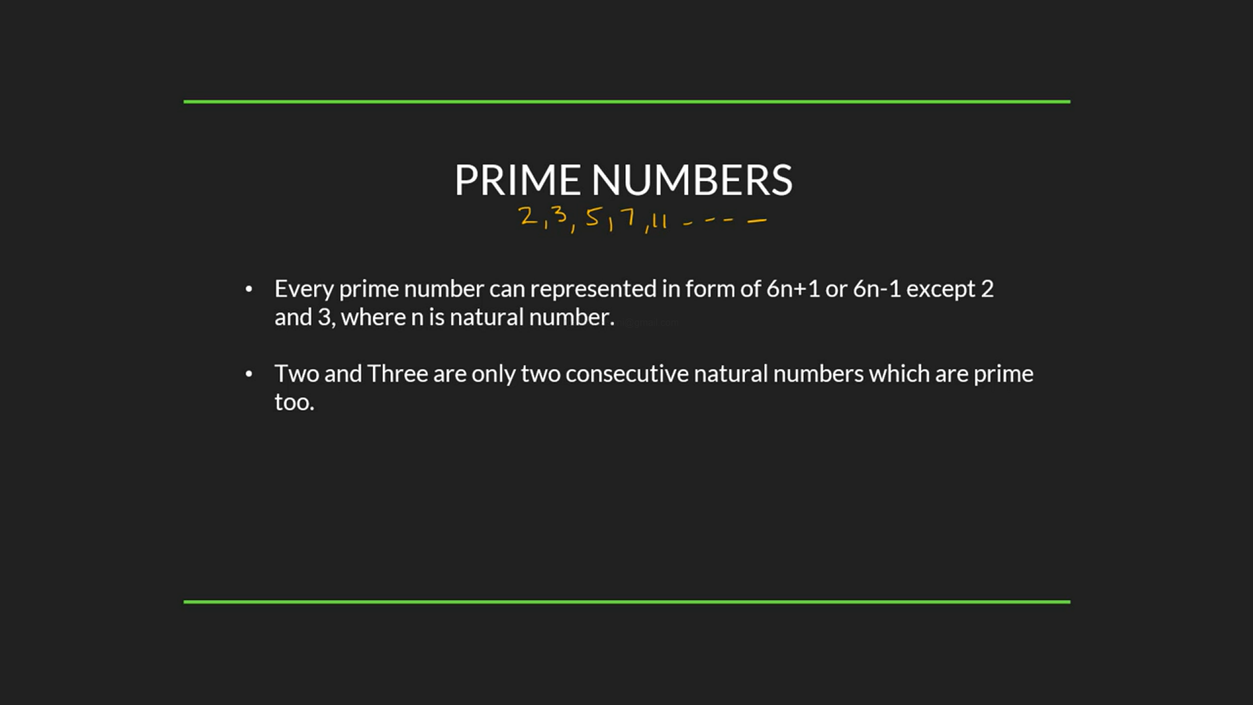

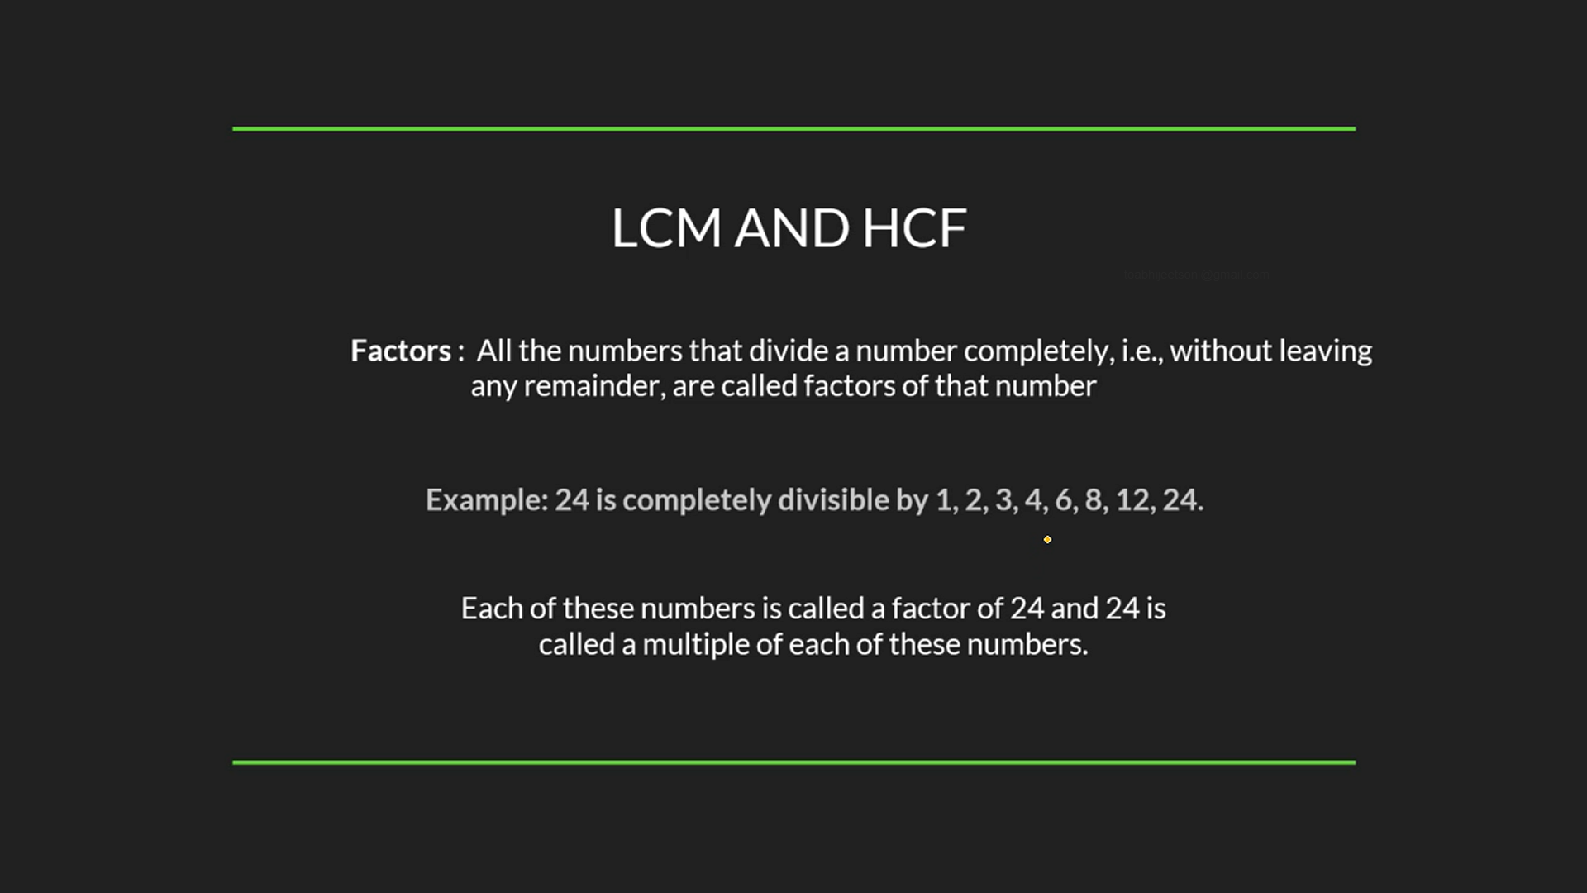

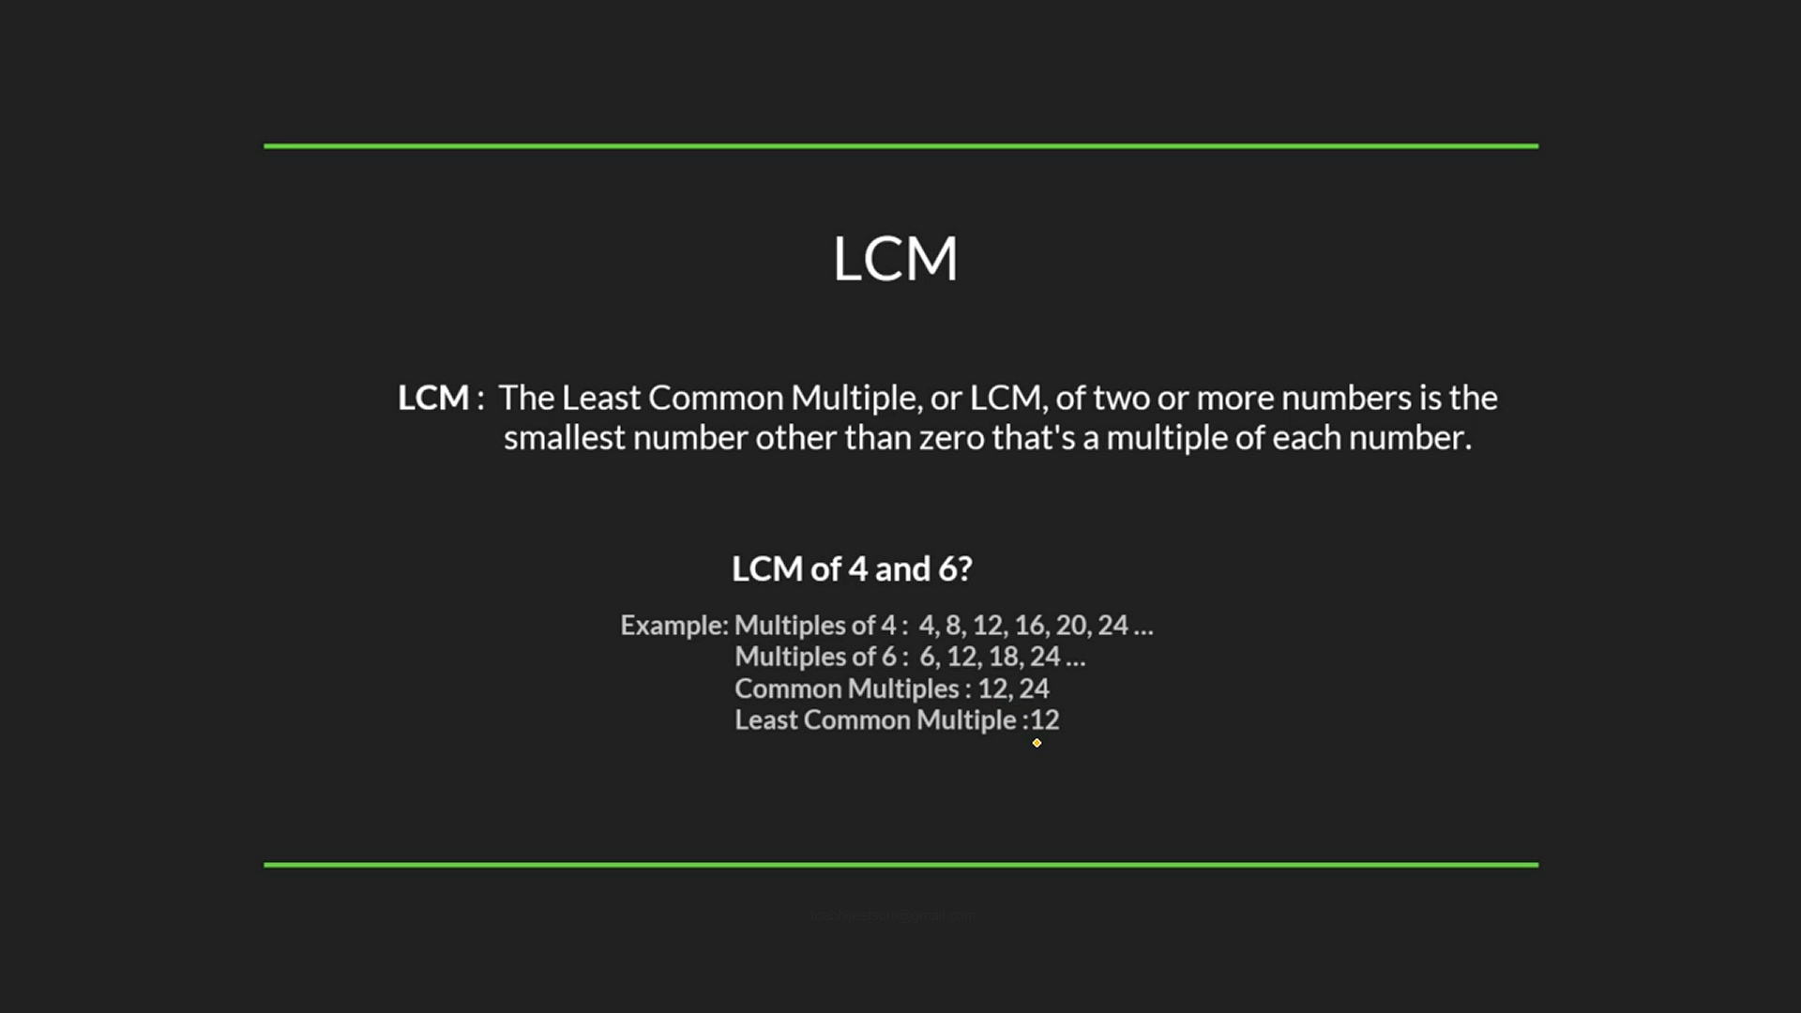

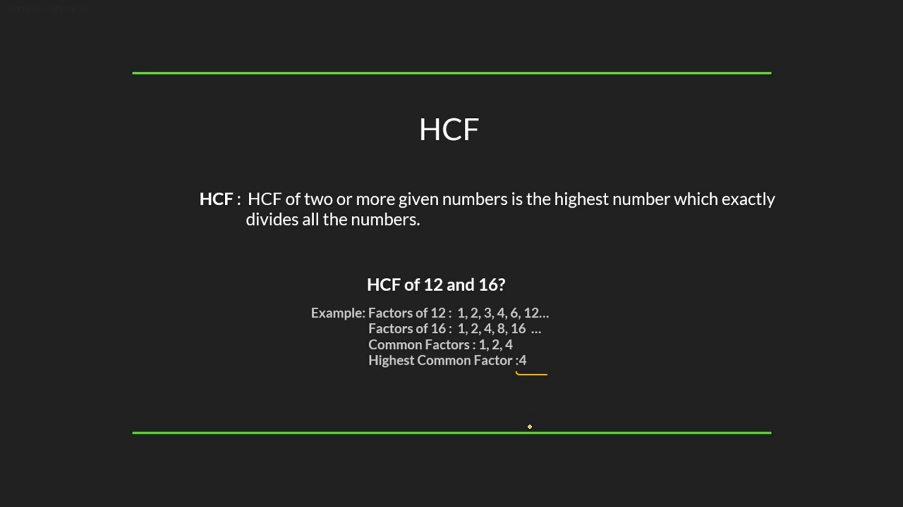

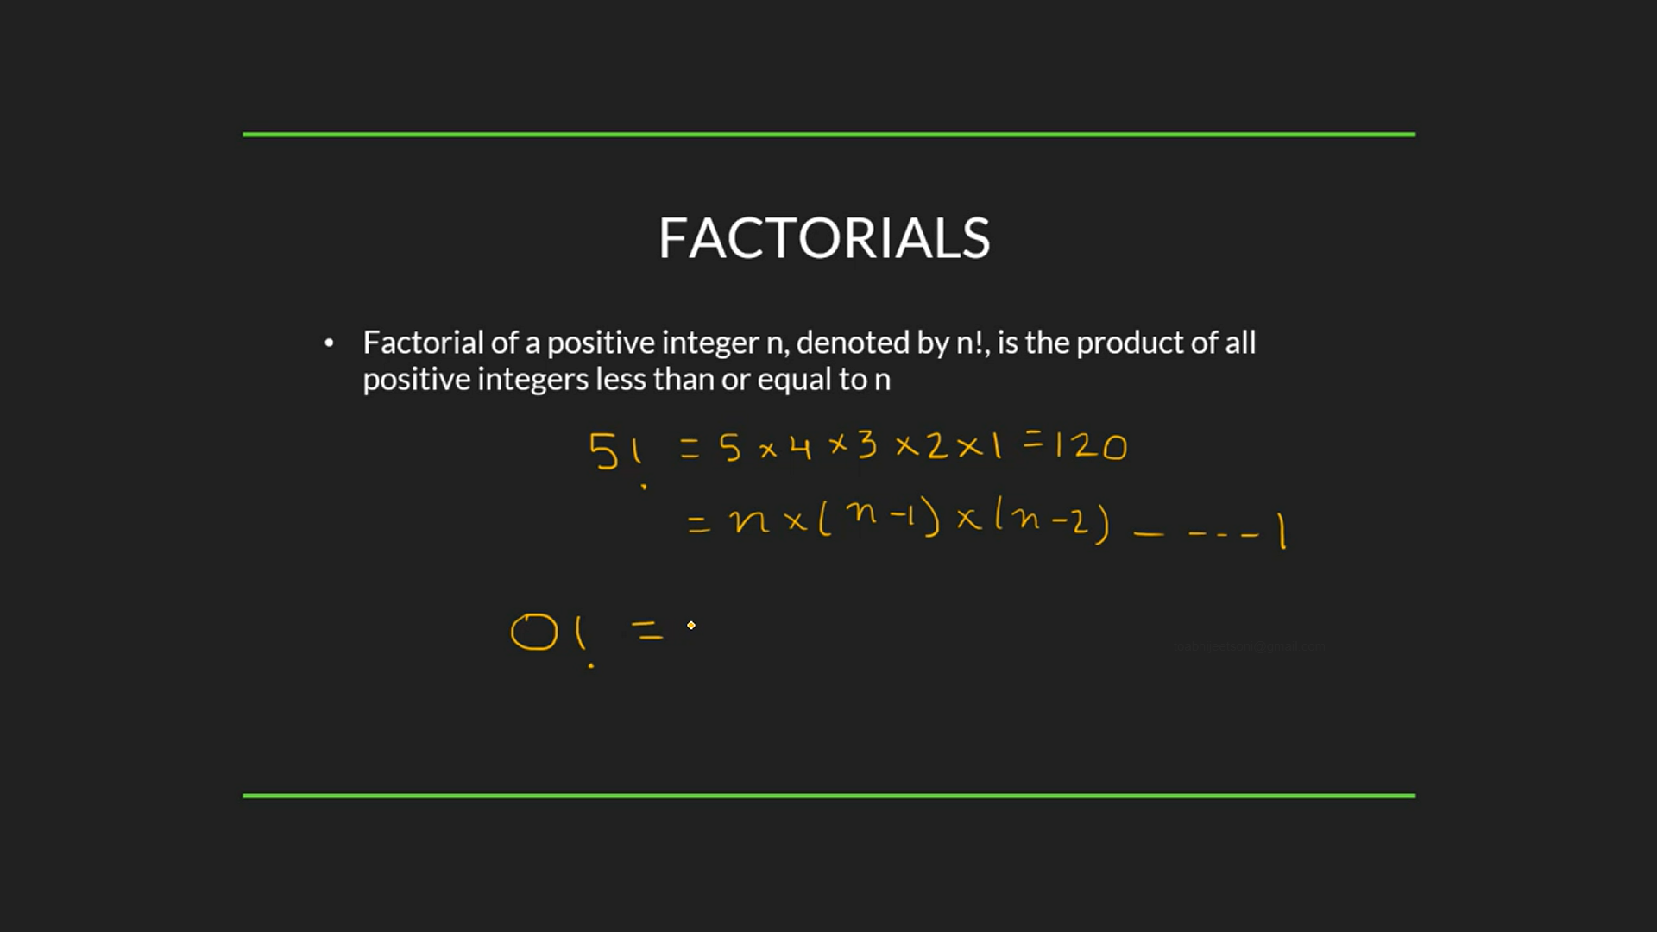

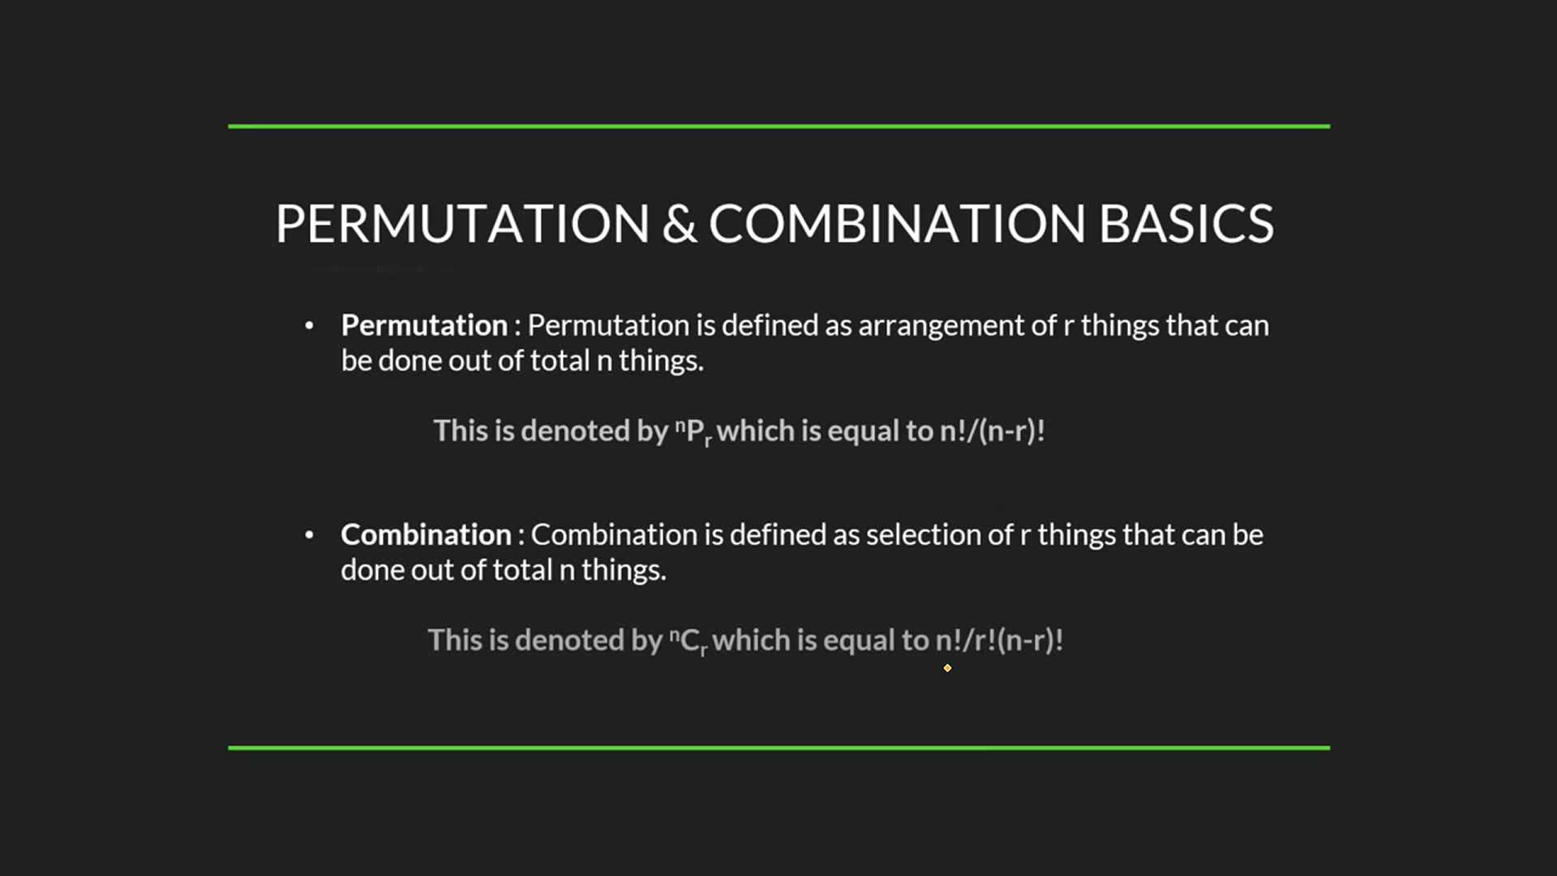

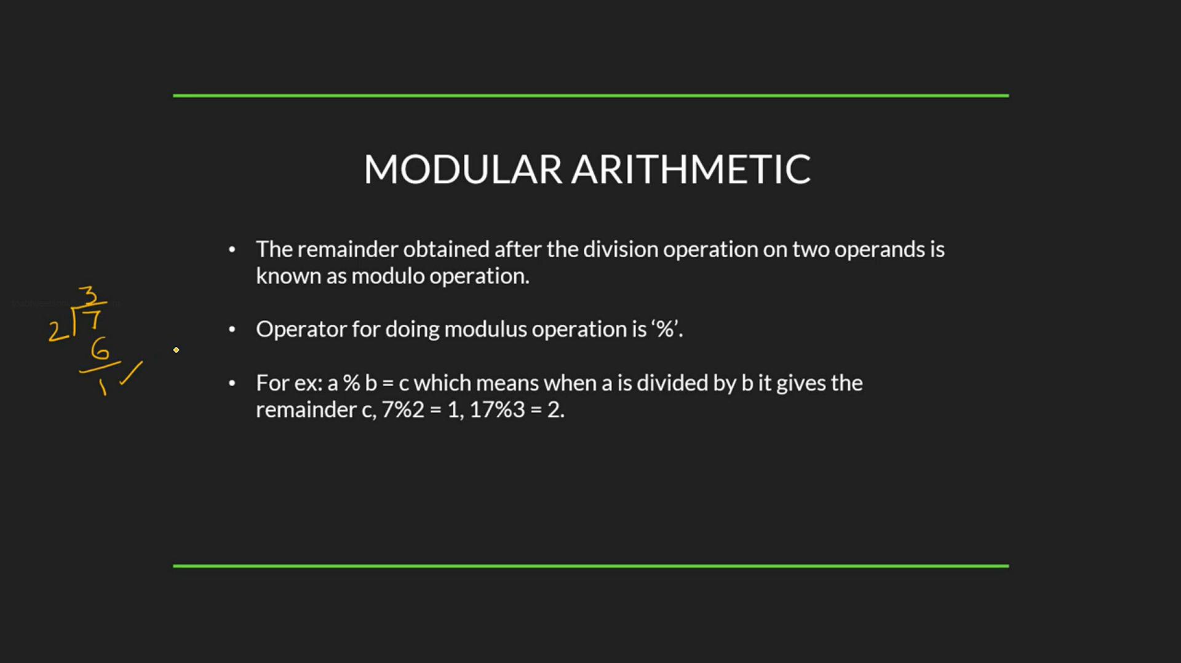

Count Digits

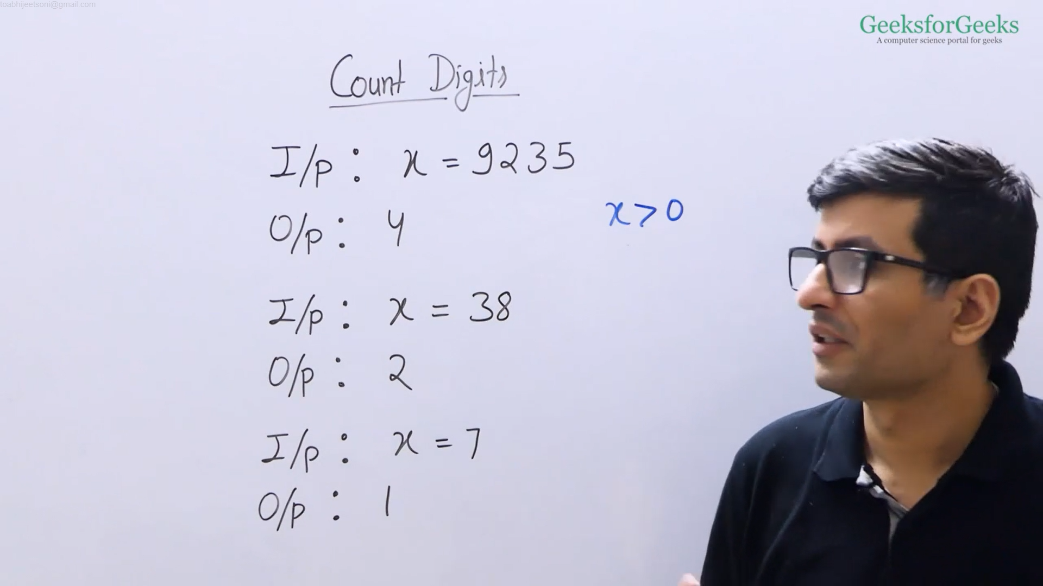

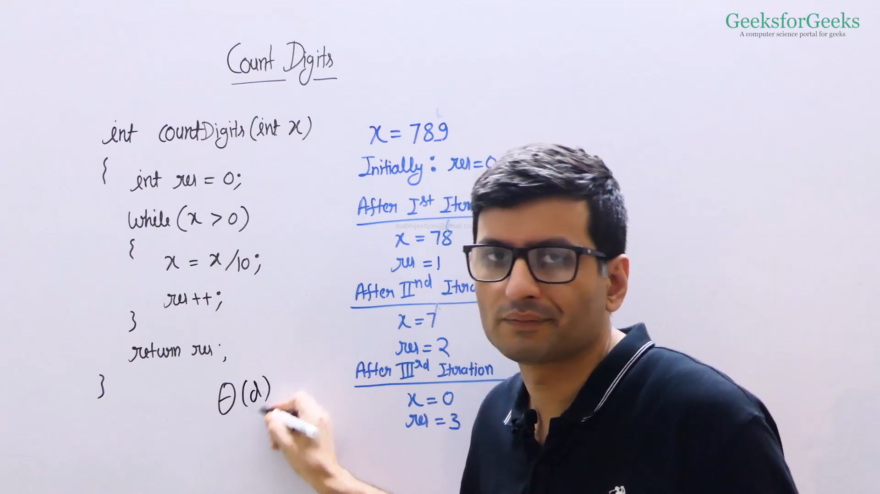

* CPP: <https://ide.geeksforgeeks.org/paMPBZVdMV>
* Java: <https://ide.geeksforgeeks.org/rqGizwkier>

Palindrome Numbers

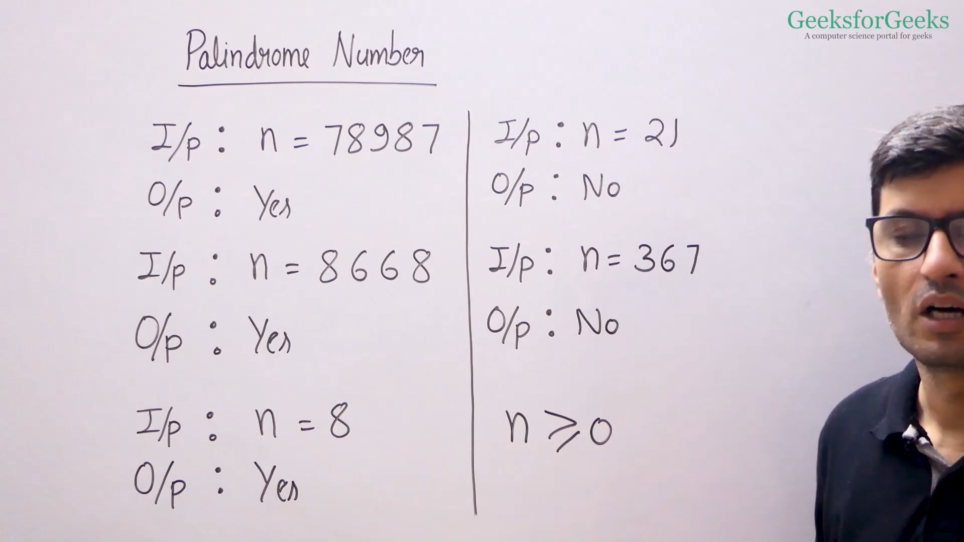

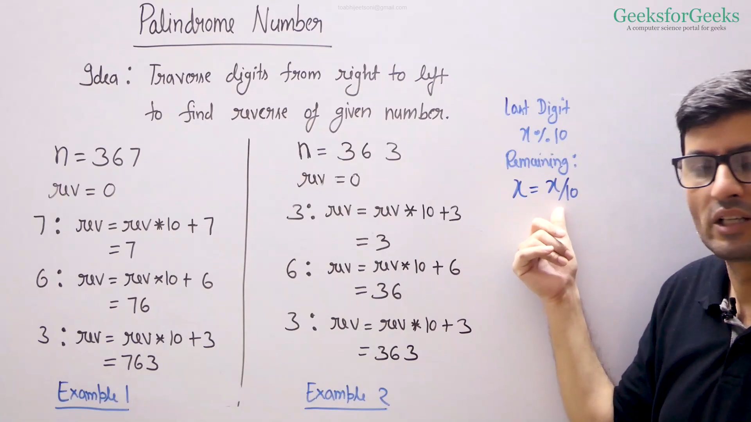

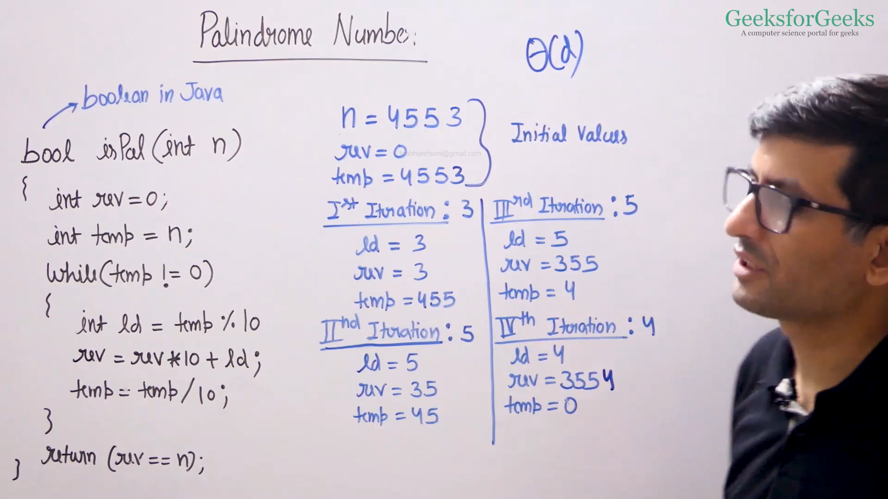

* CPP: <https://ide.geeksforgeeks.org/NkiSB5DISG>
* Java: <https://ide.geeksforgeeks.org/aXKyYkvSHp>

Factorial of a Number

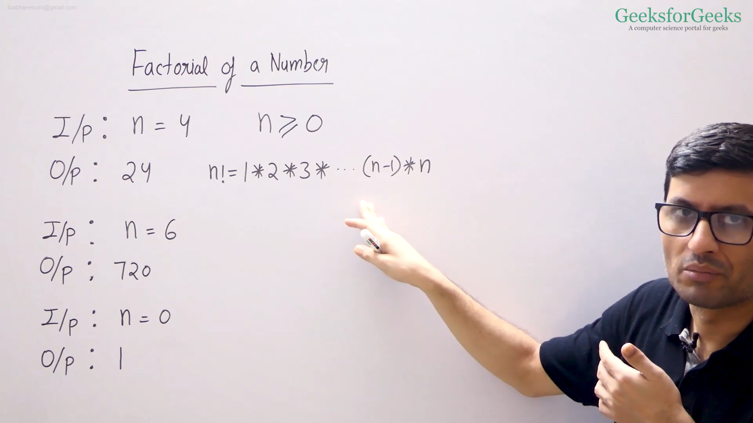

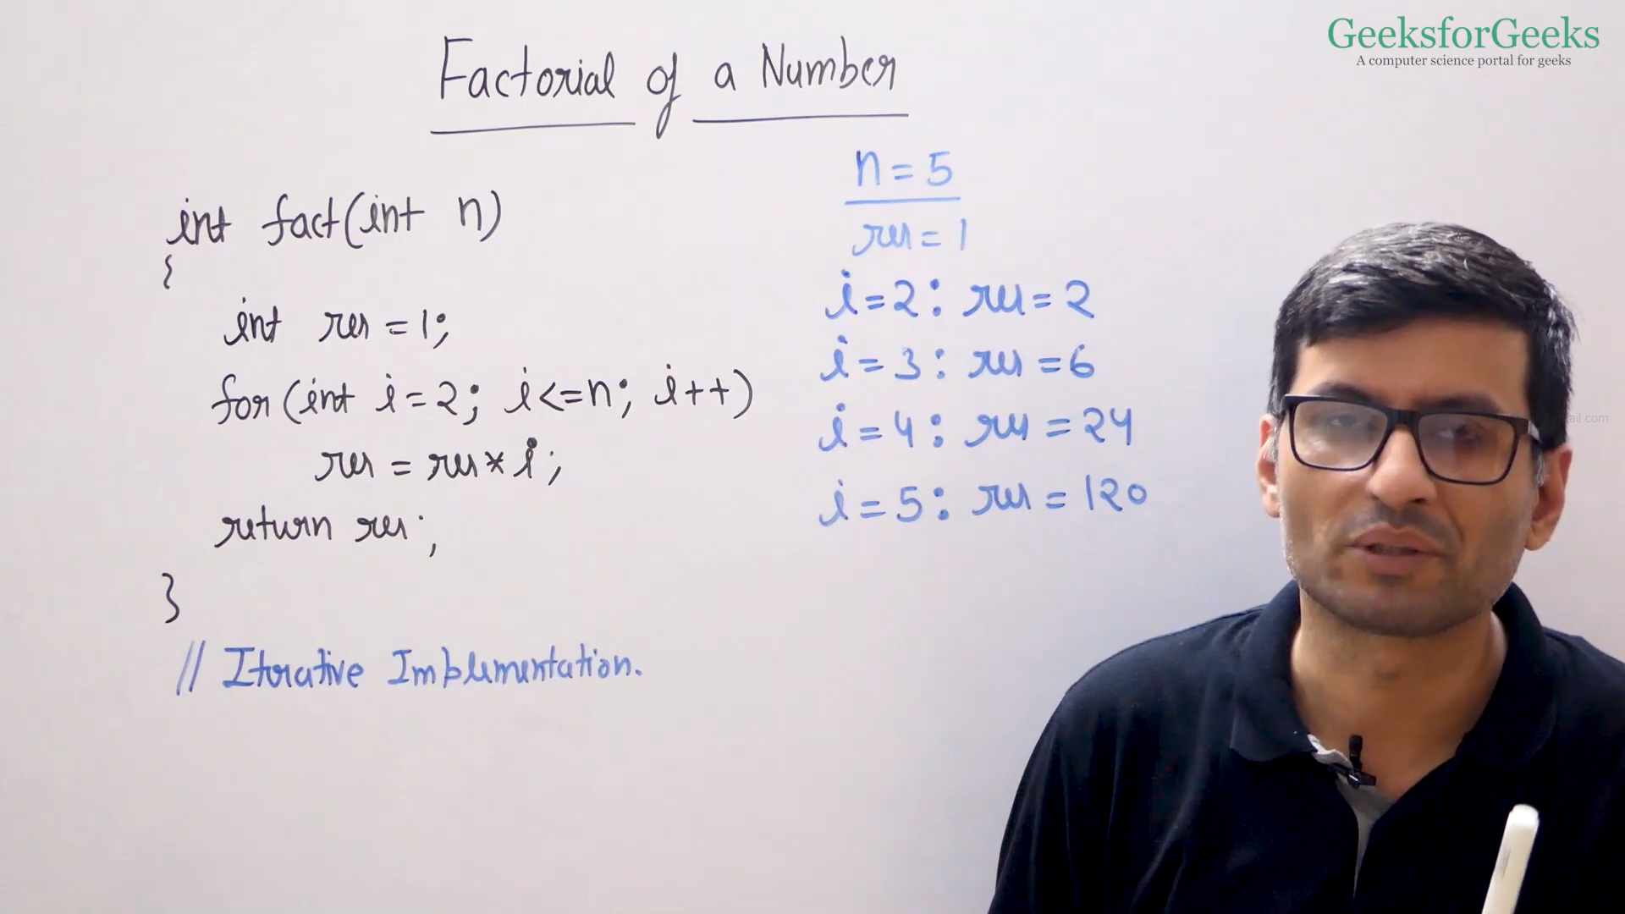

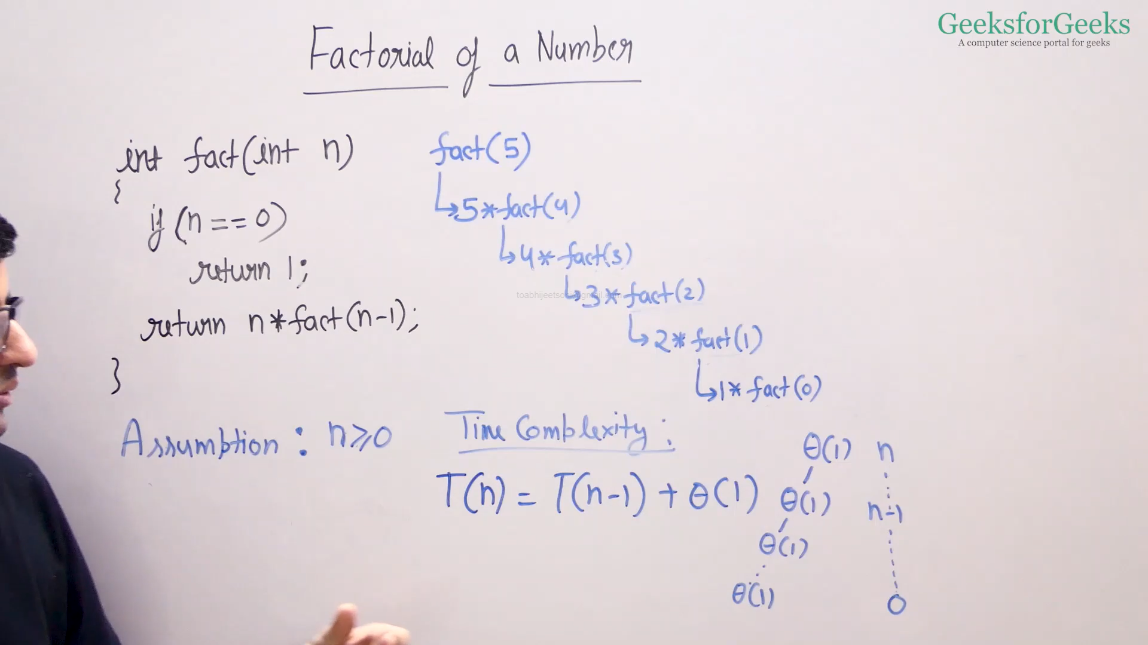

* Recursive Code
  + CPP: <https://ide.geeksforgeeks.org/e5ObKWiVJg>
  + Java: <https://ide.geeksforgeeks.org/T5k8gr4PVG>
* Iterative Code
  + CPP: <https://ide.geeksforgeeks.org/dnkKaPezcH>
  + Java: <https://ide.geeksforgeeks.org/H0oo72wo3D>

Trailing Zeros in Factorial

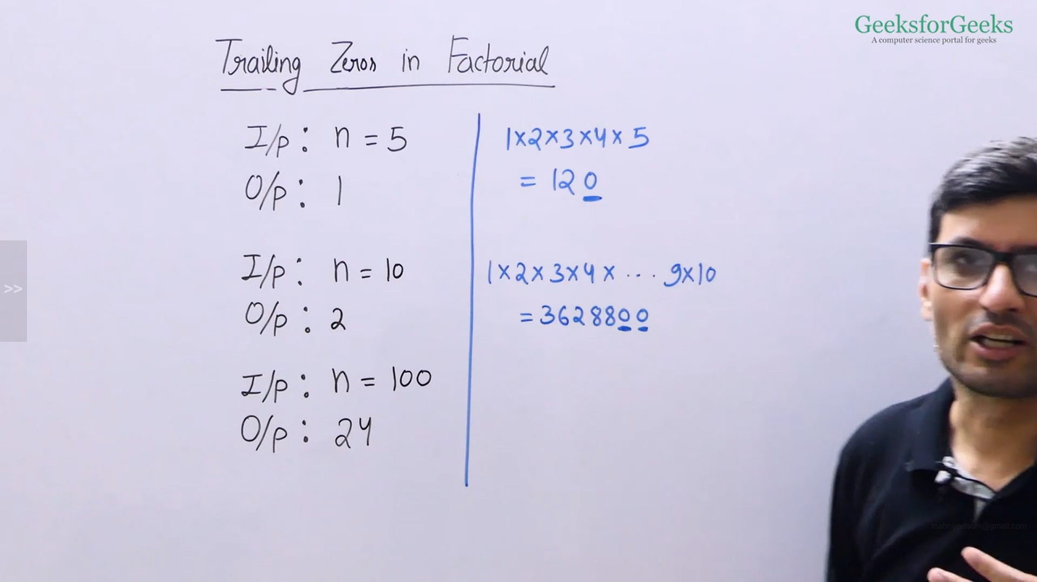

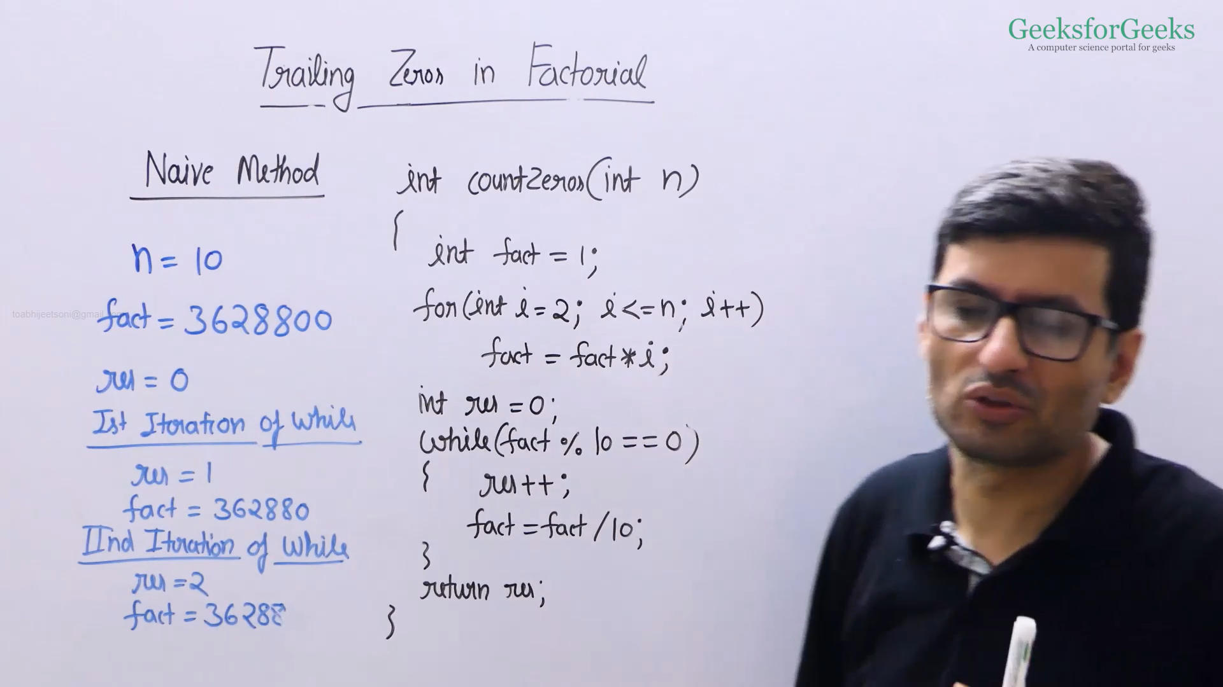

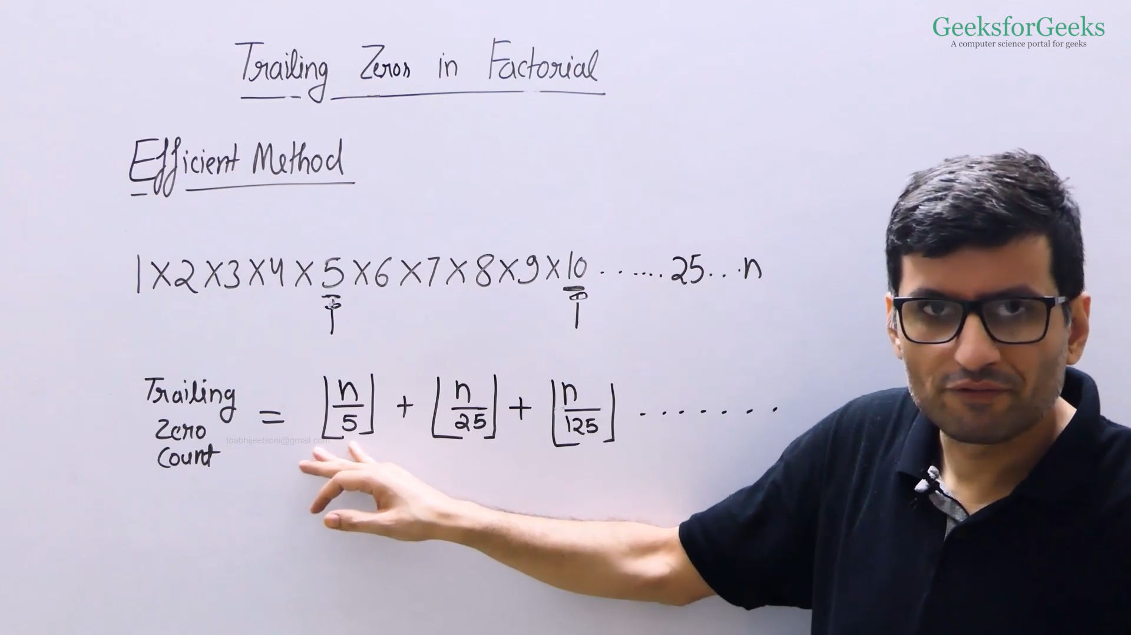

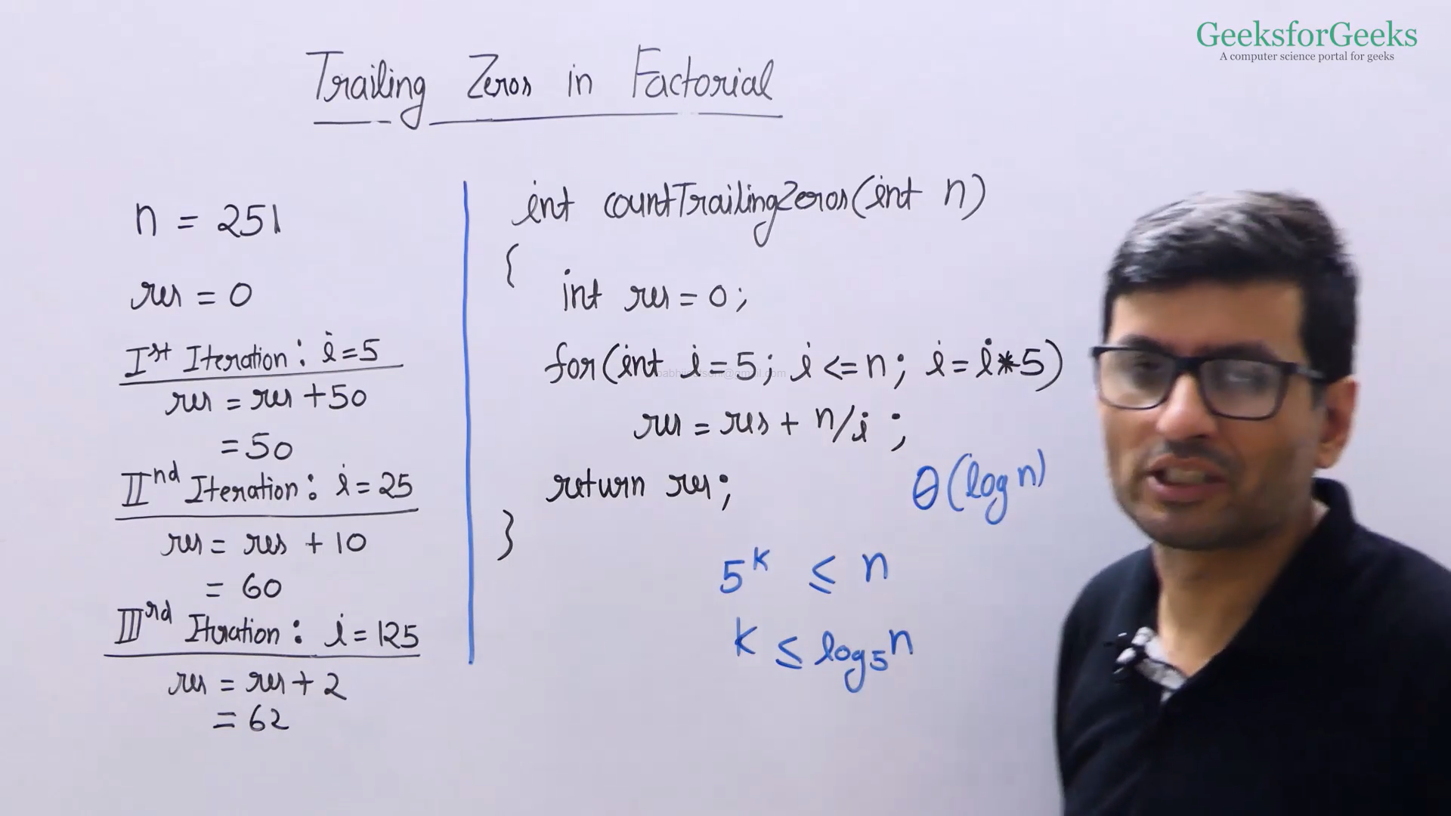

* CPP: <https://ide.geeksforgeeks.org/KxrWqkqemN>
* Java: <https://ide.geeksforgeeks.org/jNBG35z0gd>

GCD or HCF of two Numbers

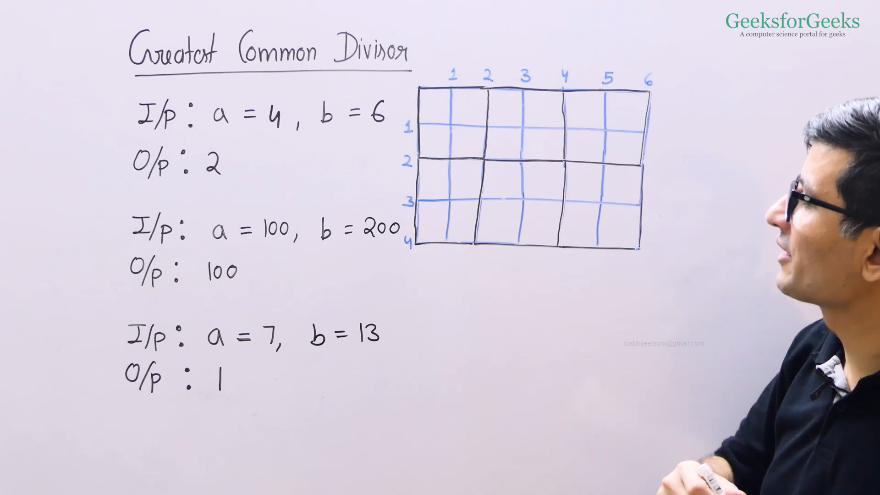

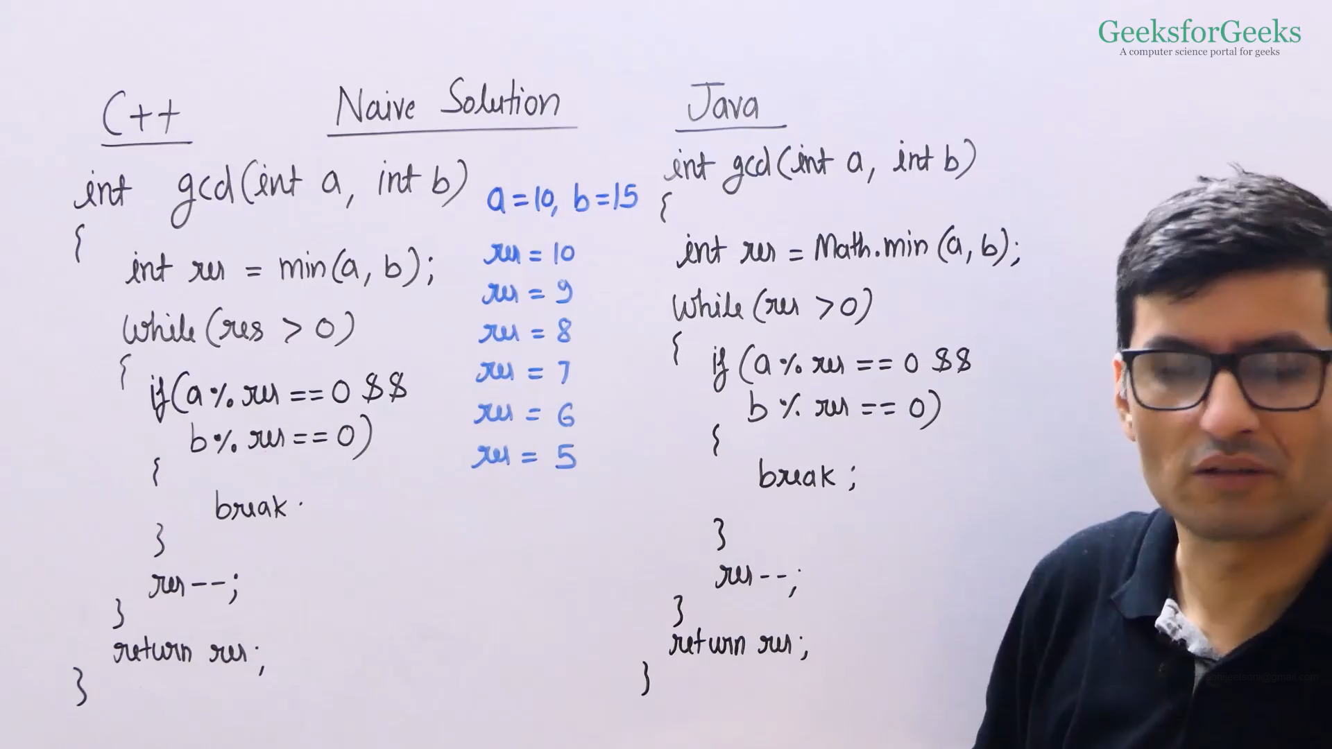

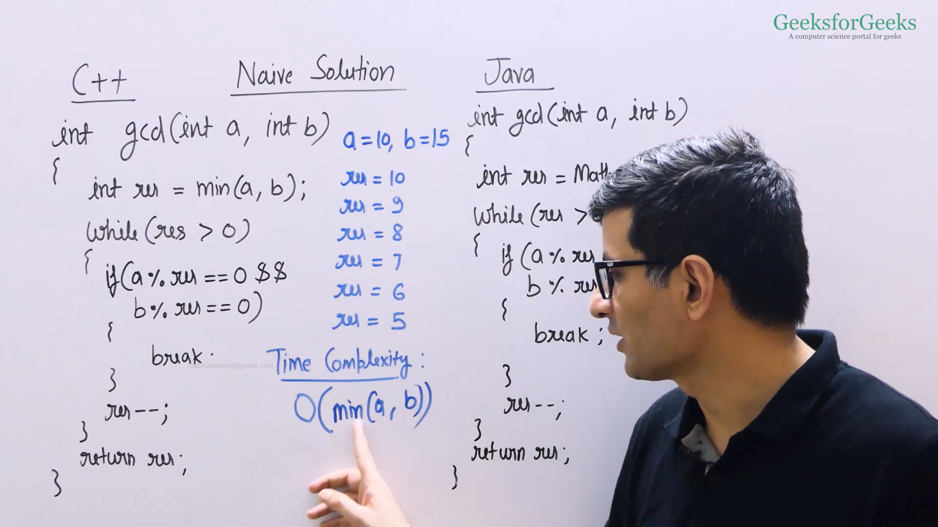

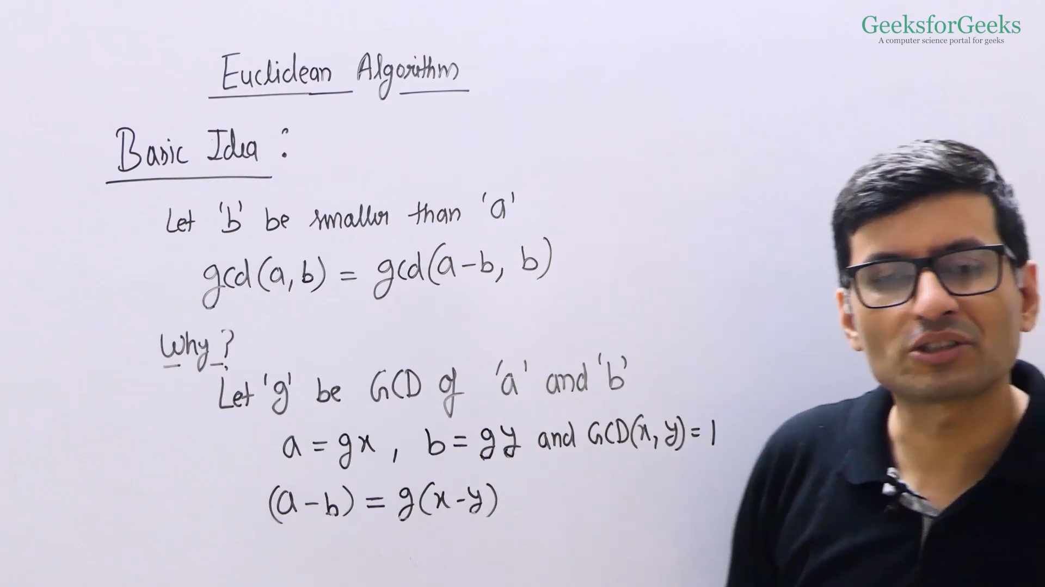

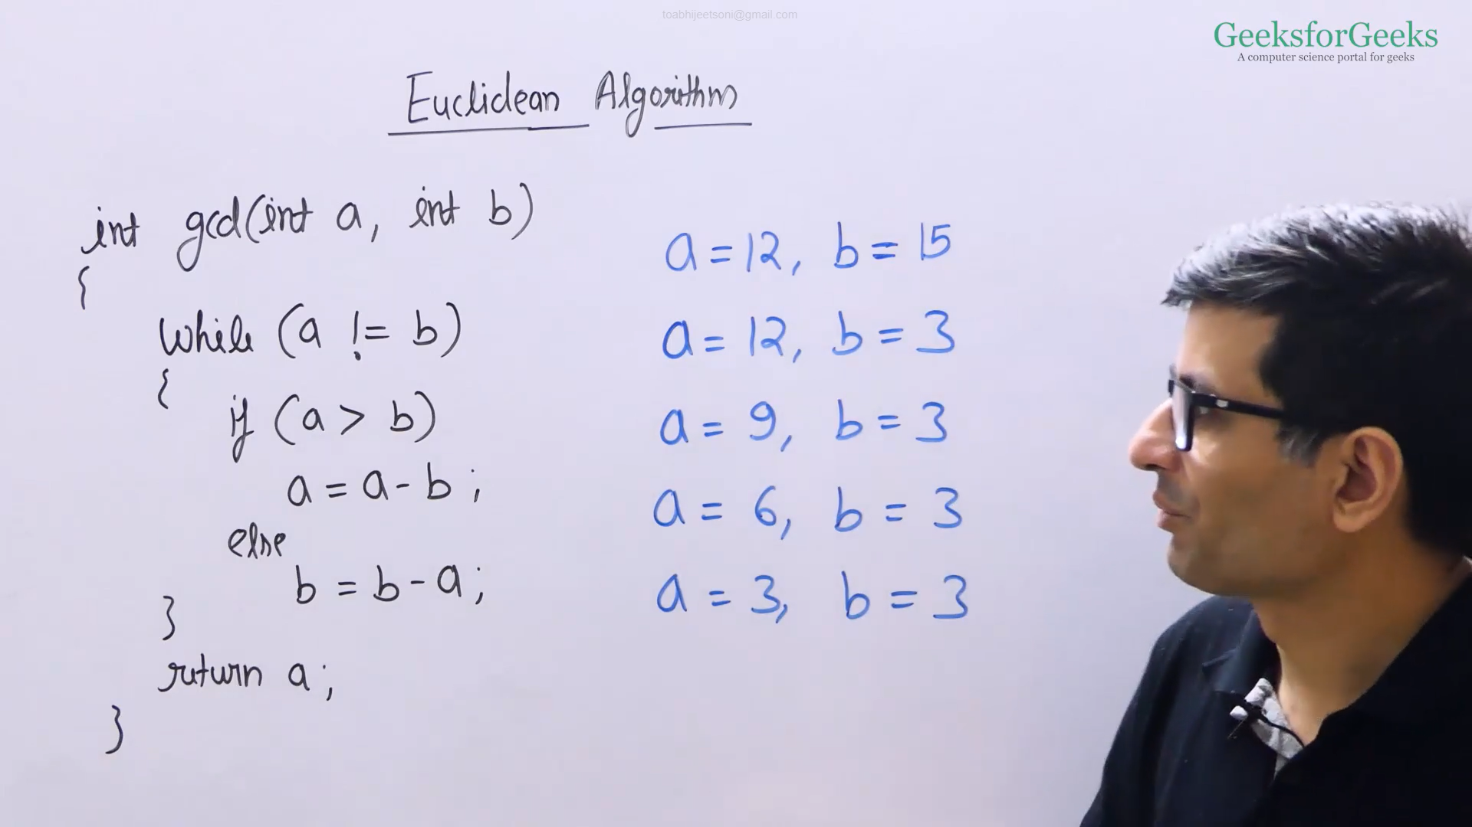

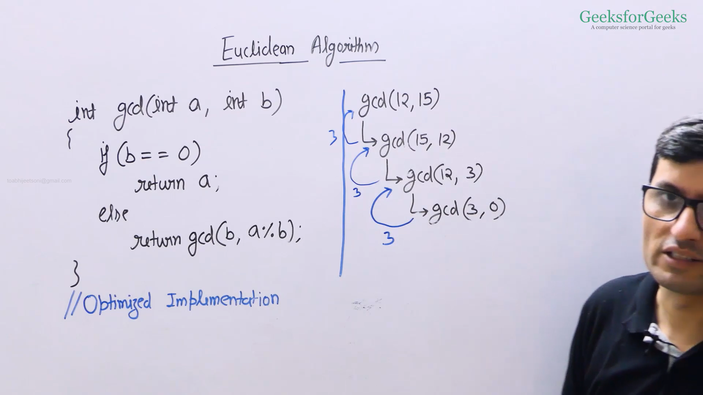

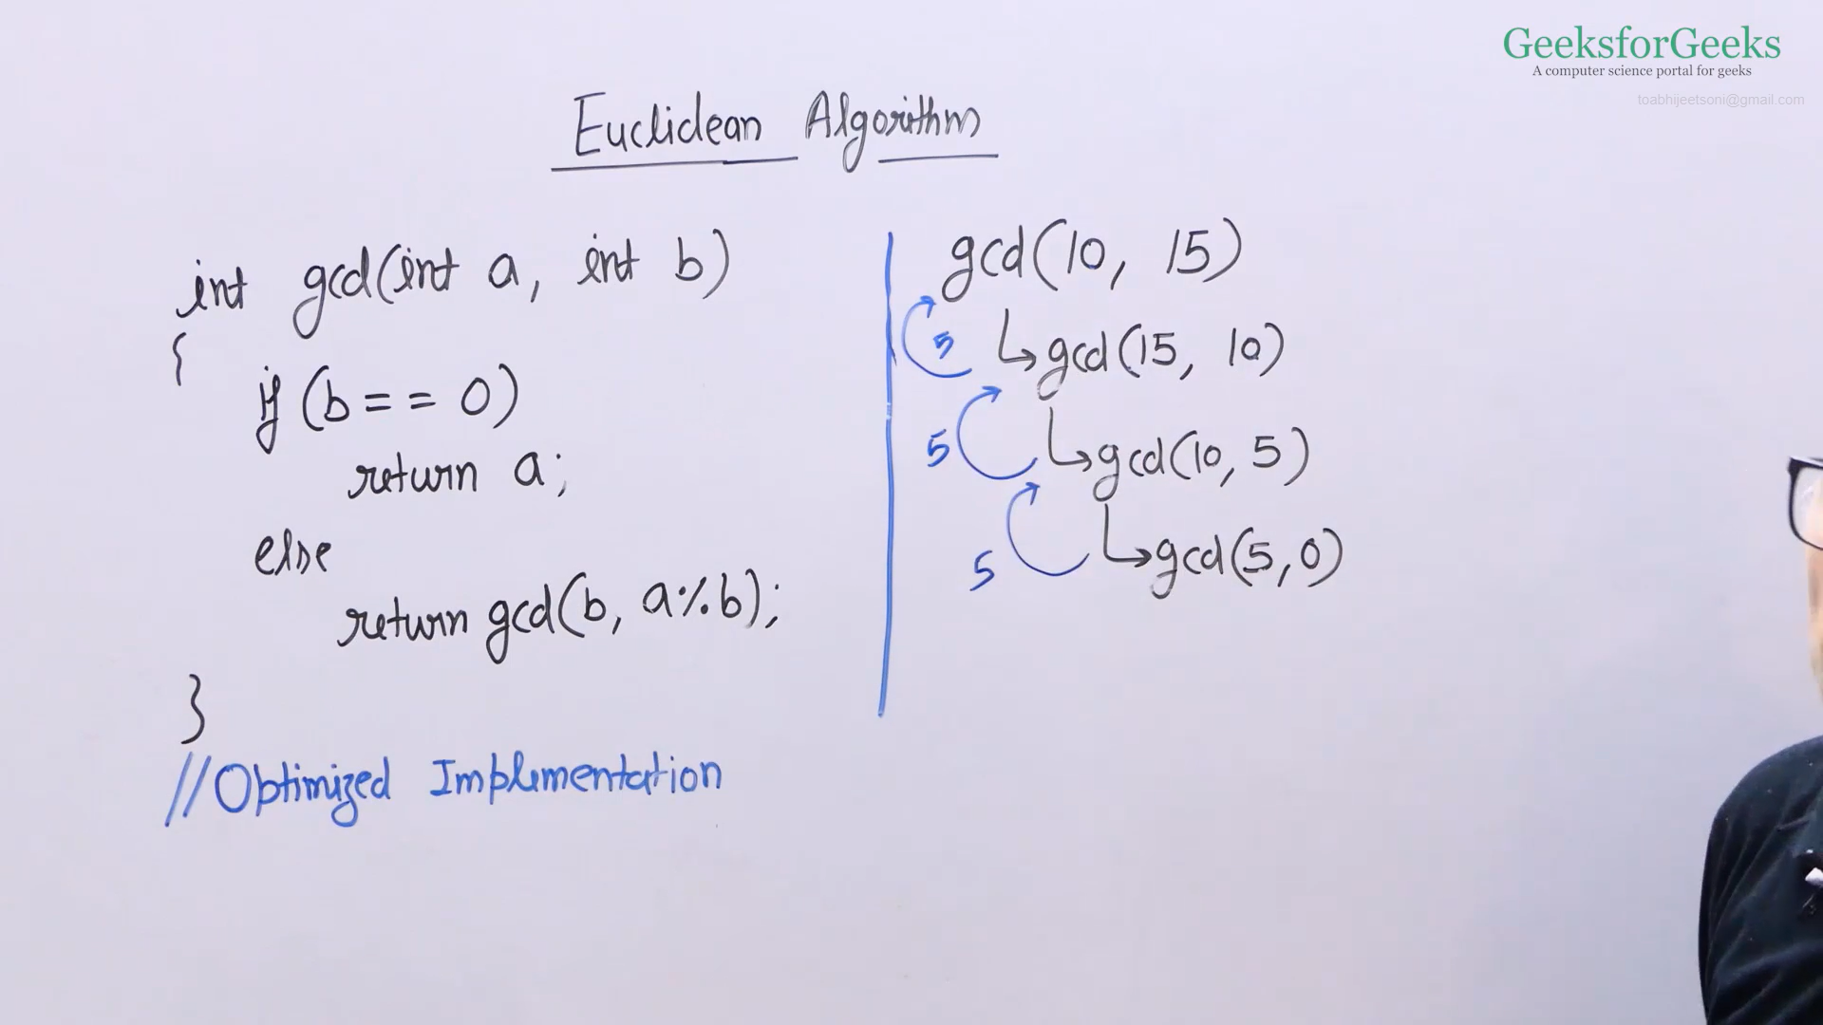

* Euclidean Algorithm Code
  + CPP: <https://ide.geeksforgeeks.org/2Kogq8ZSr2>
  + Java: <https://ide.geeksforgeeks.org/krJL7txfcu>
* Optimized Euclidean Algorithm Code
  + CPP: <https://ide.geeksforgeeks.org/DVTQQ1NZji>
  + Java: <https://ide.geeksforgeeks.org/Jm1hDj4vKC>

LCM of Two Numbers

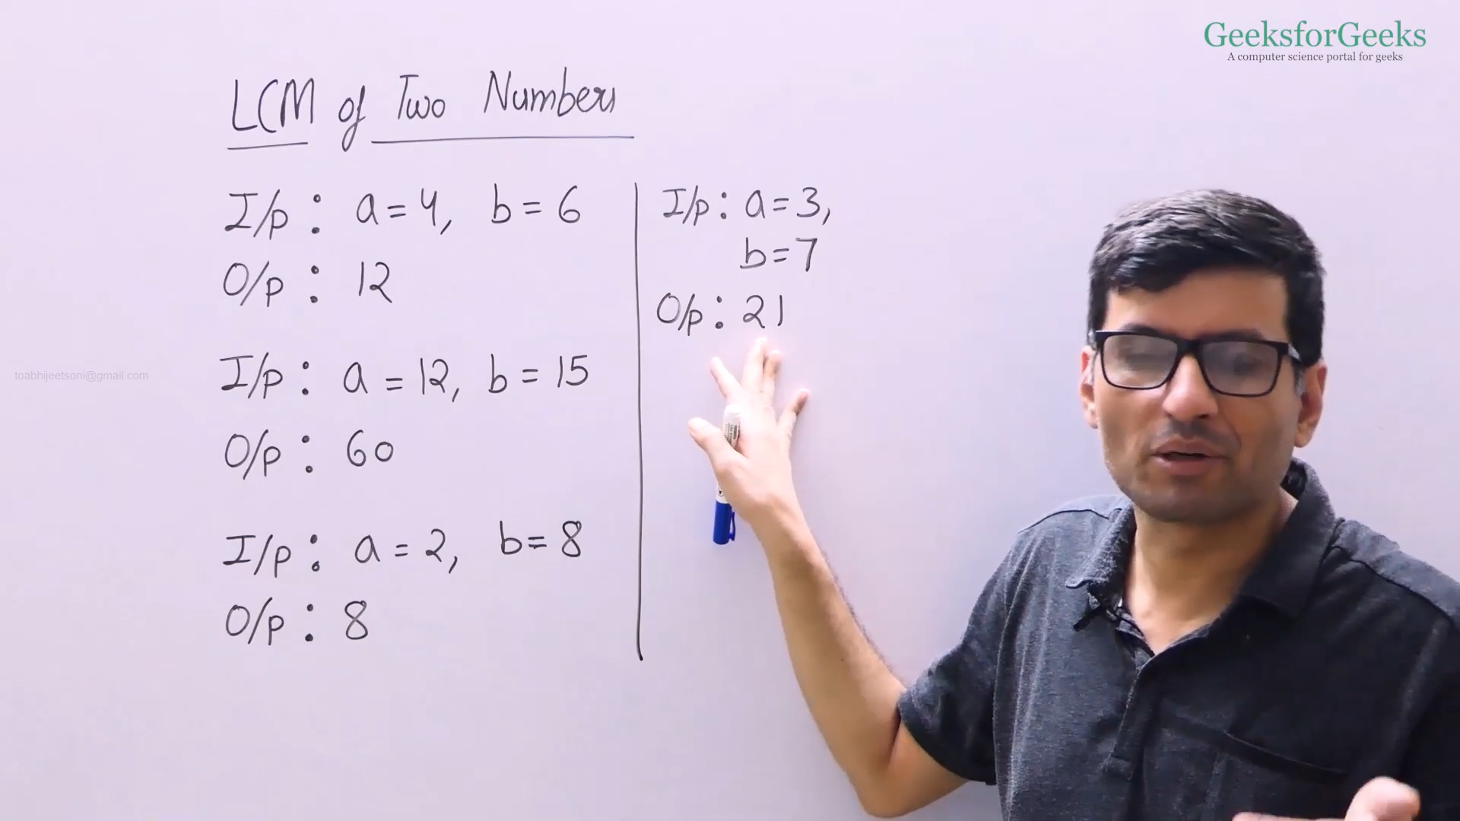

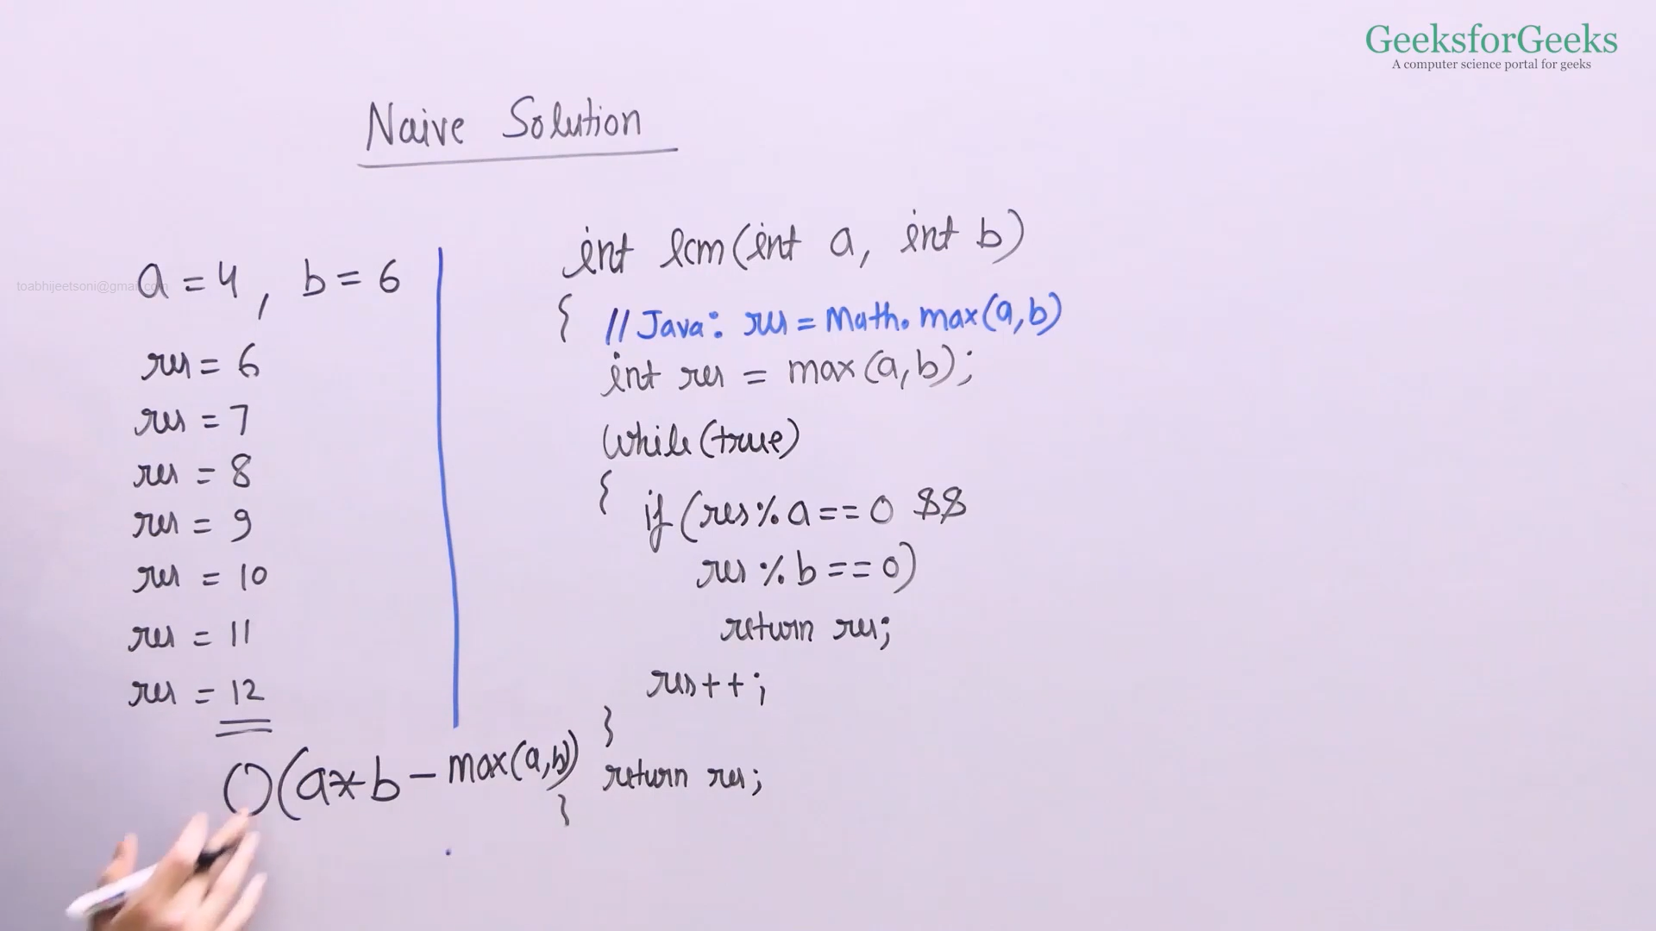

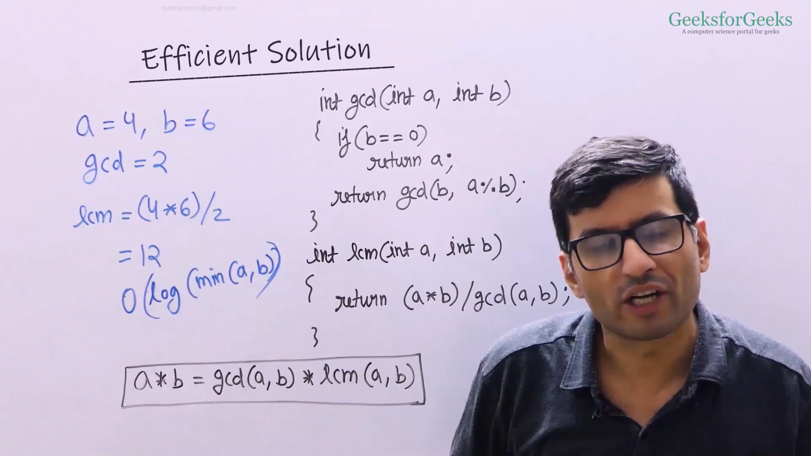

* CPP: <https://ide.geeksforgeeks.org/cUkWL1UIdu>
* Java: <https://ide.geeksforgeeks.org/ucqoME7keP>

Check for Prime

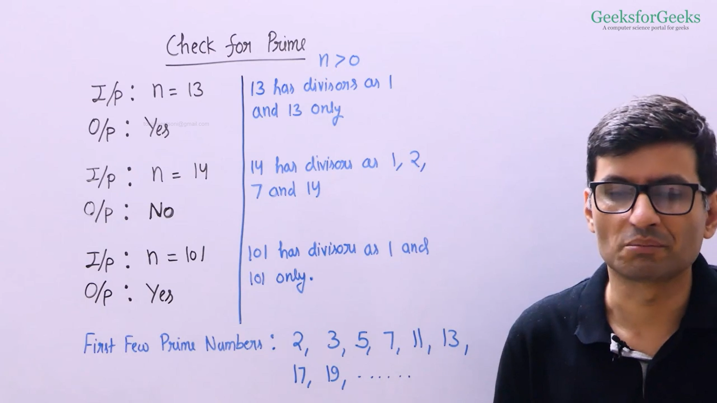

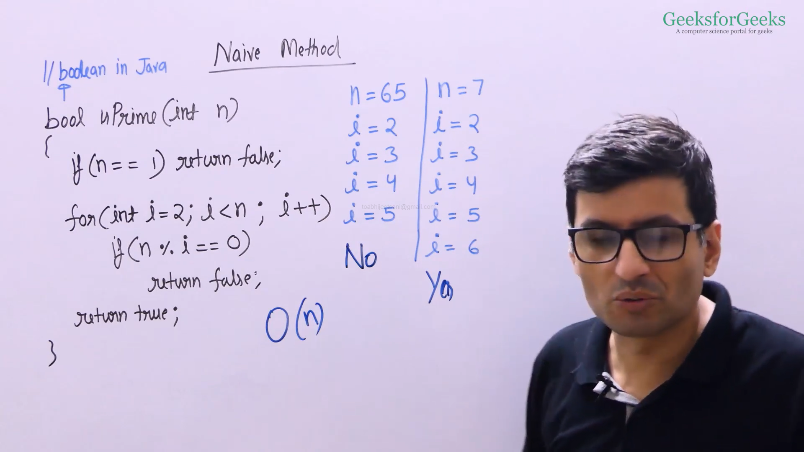

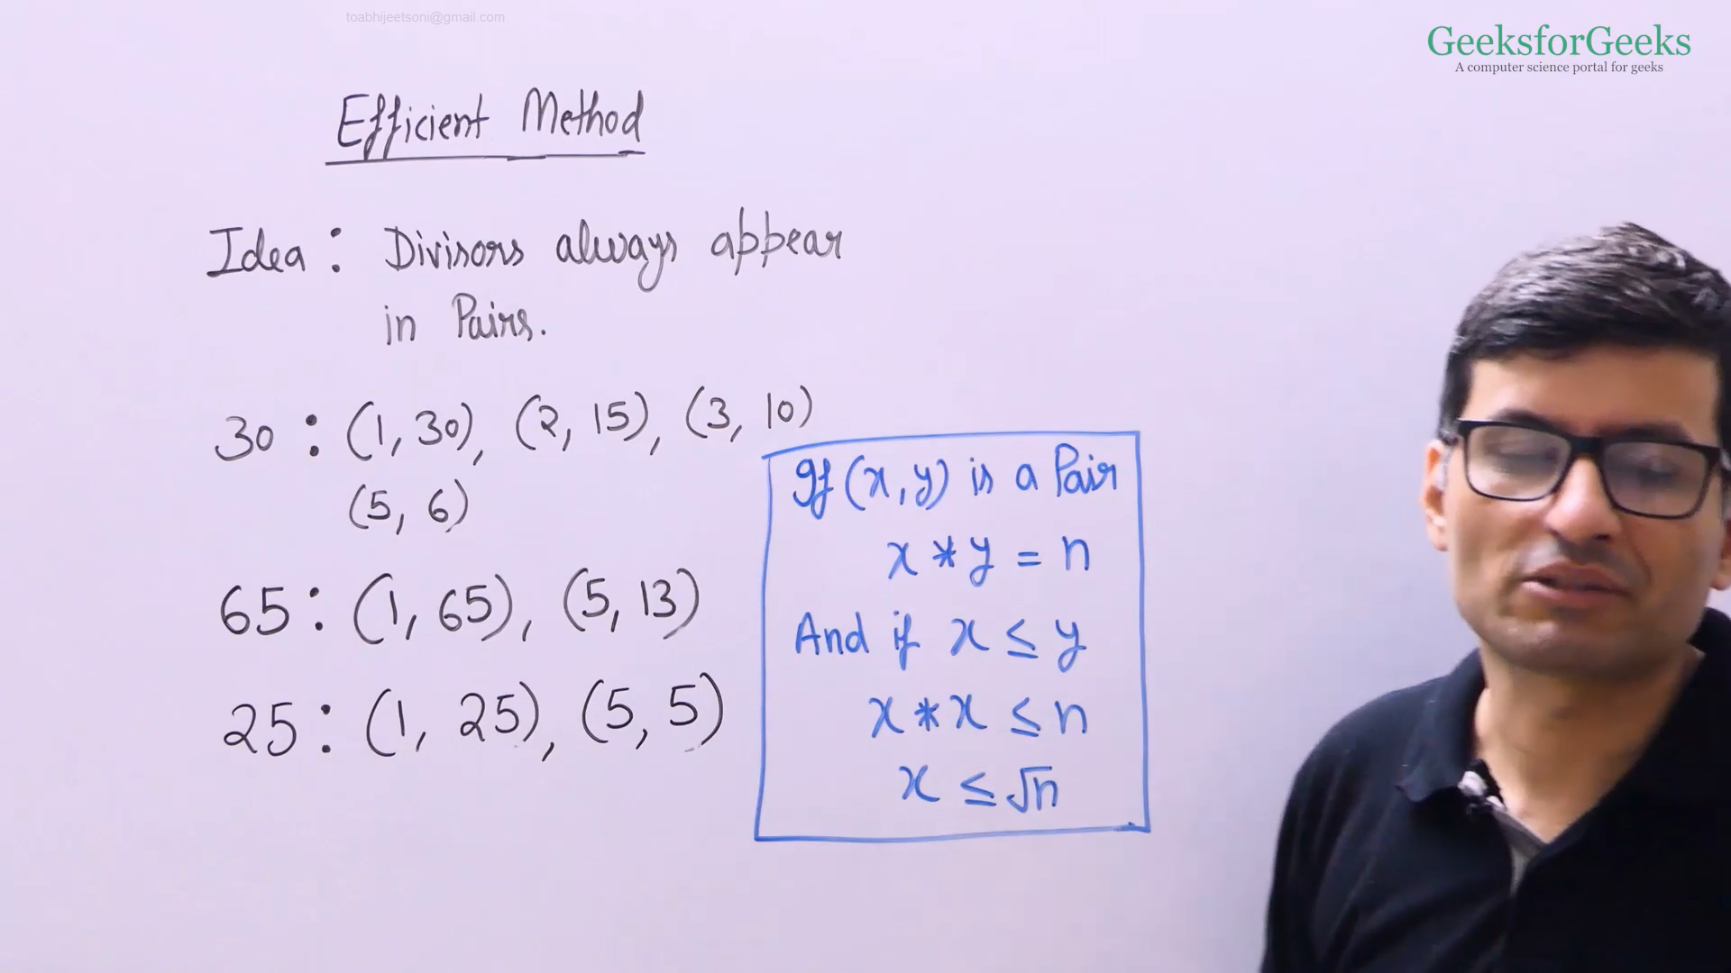

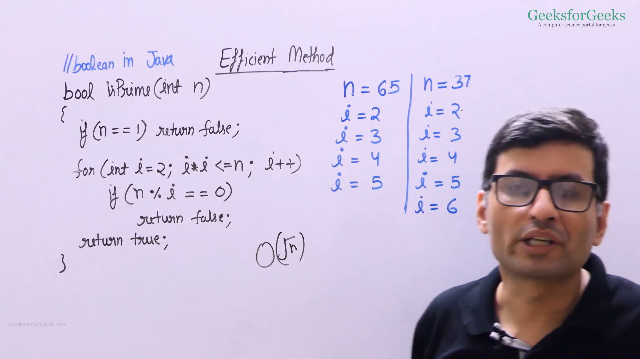

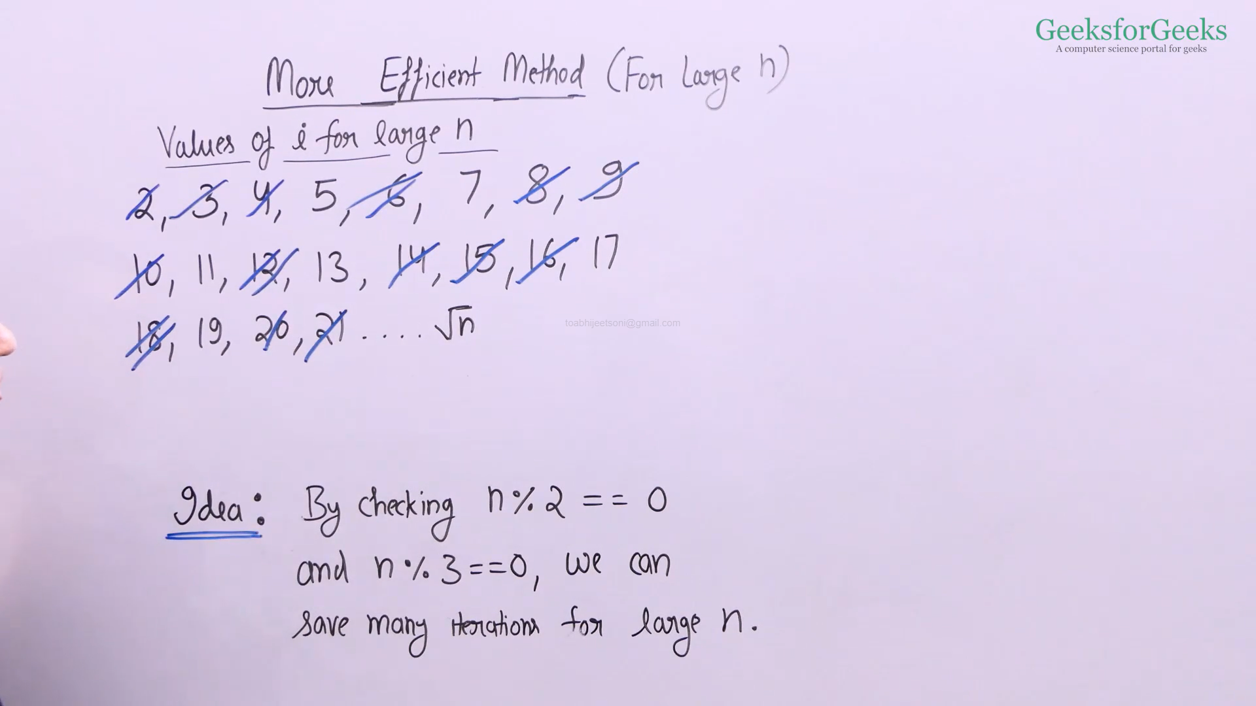

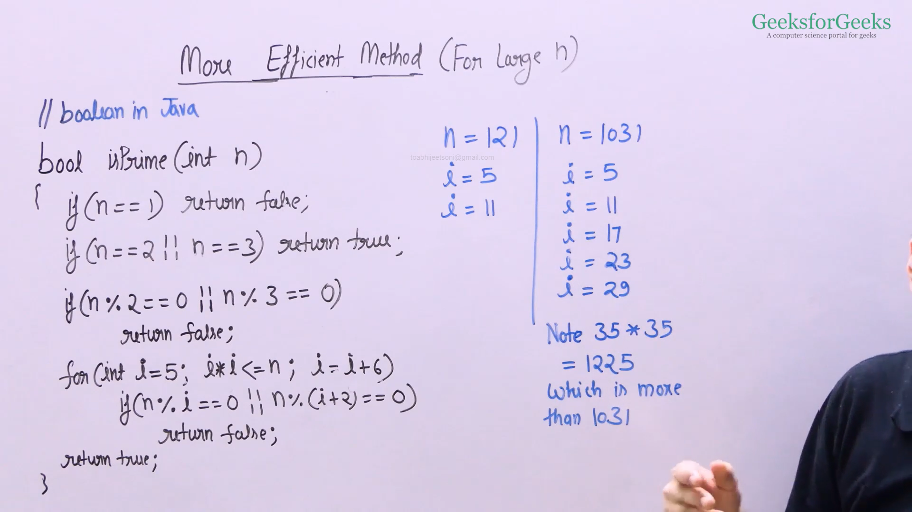

* Efficient Code
  + CPP: <https://ide.geeksforgeeks.org/OOF8iVVsbv>
  + Java: <https://ide.geeksforgeeks.org/DOI1KDAj2e>
* More Efficient Code(for large numbers)
  + CPP: <https://ide.geeksforgeeks.org/fwhdlIboxM>
  + Java: <https://ide.geeksforgeeks.org/FAY7ascbXO>

Prime Factors

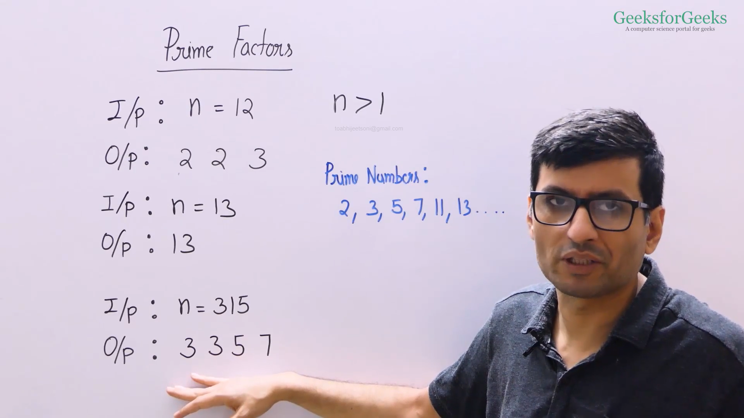

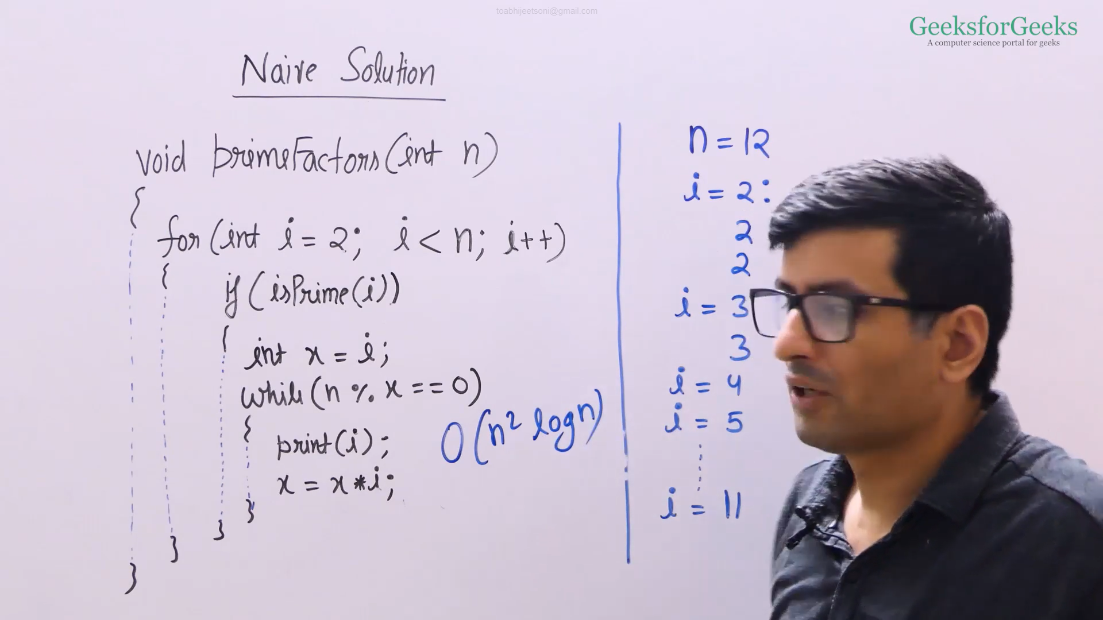

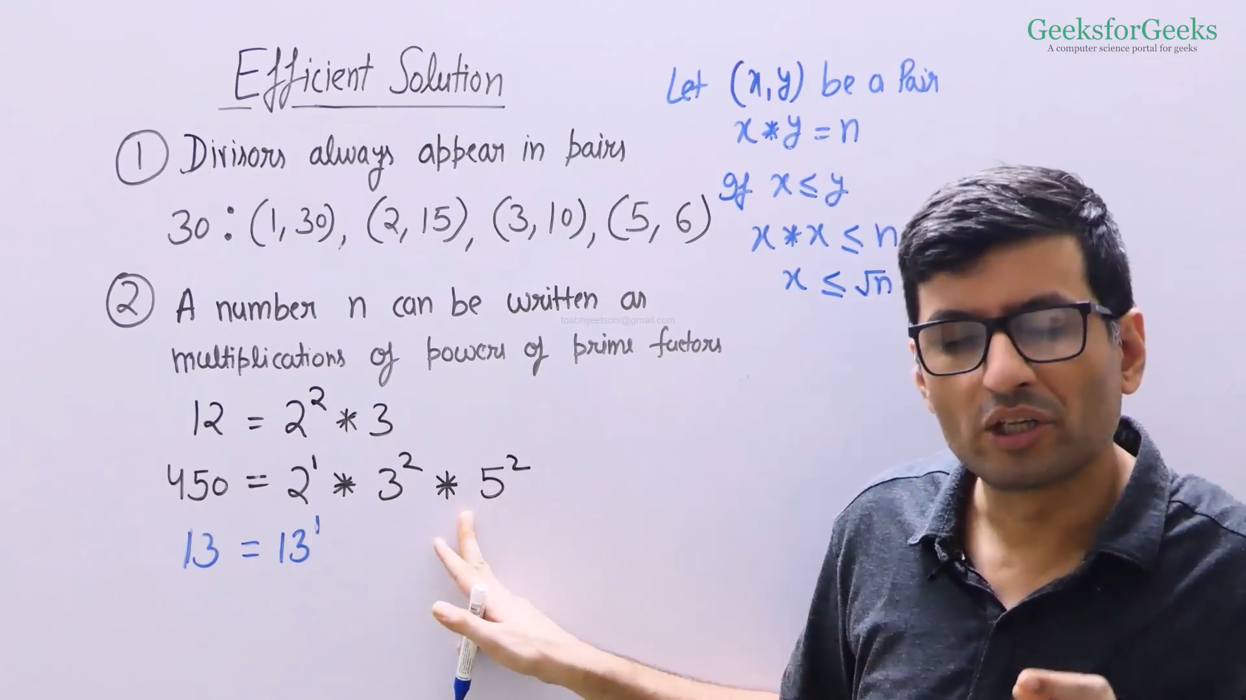

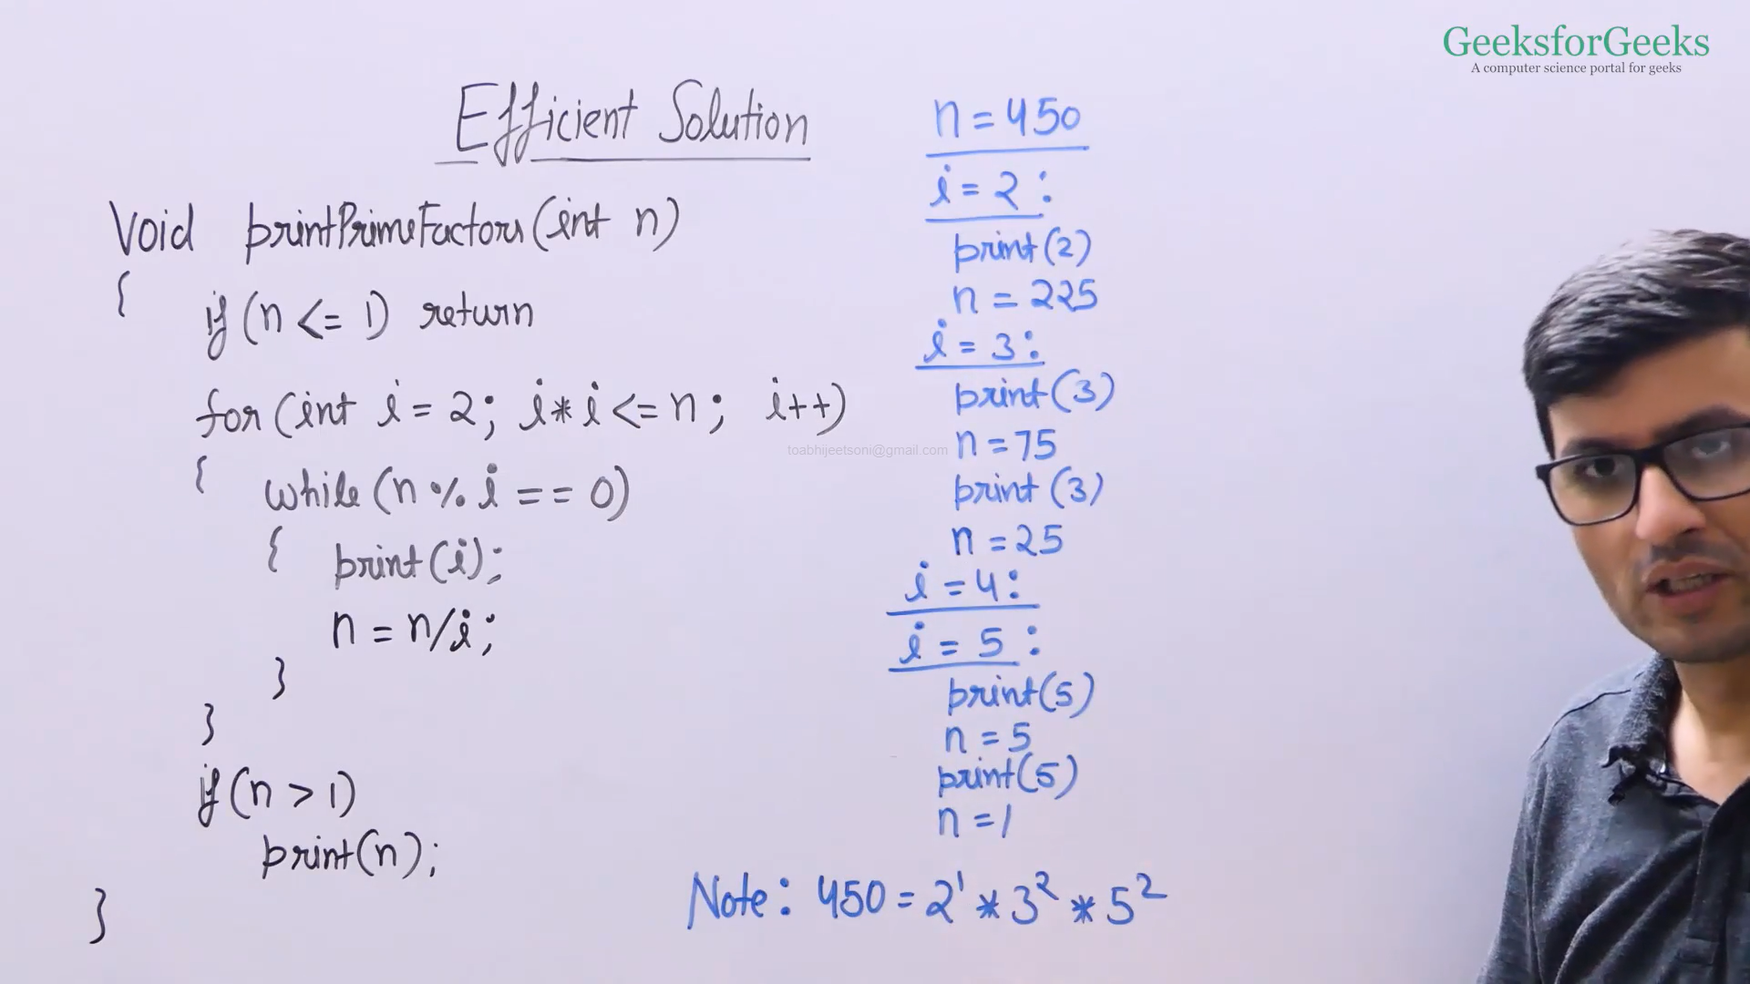

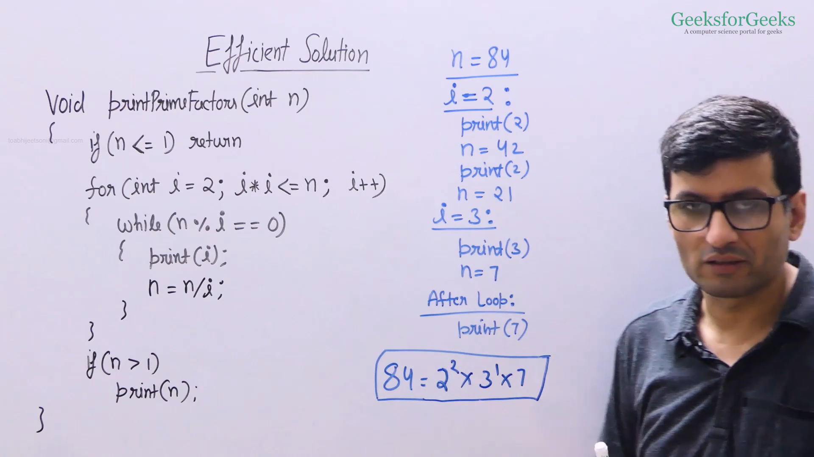

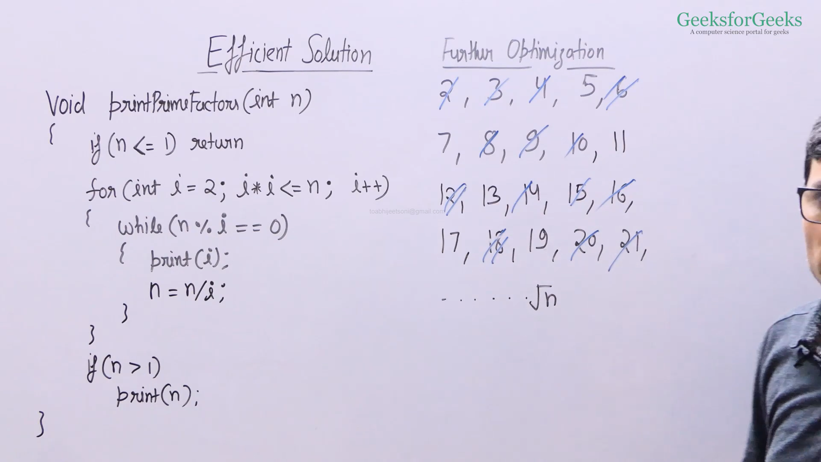

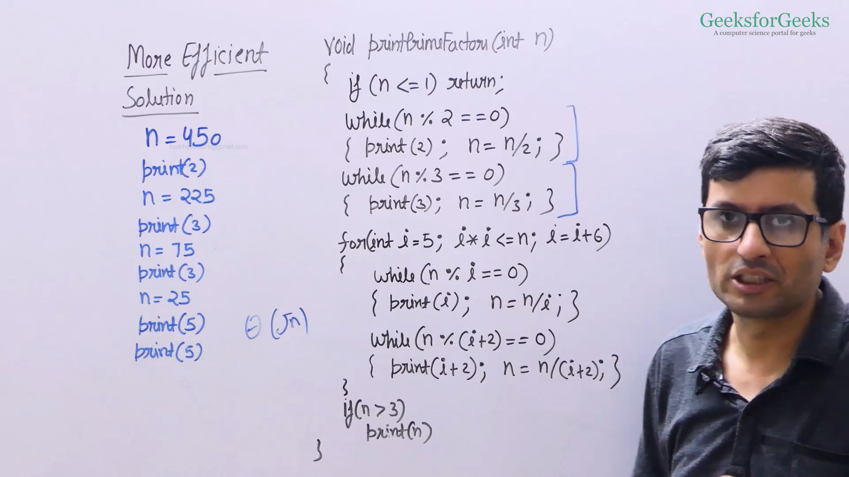

* Efficient Code
  + CPP: <https://ide.geeksforgeeks.org/I3PiLRDM9X>
  + Java: <https://ide.geeksforgeeks.org/grprGXewC5>
* More Efficient Code
  + CPP: <https://ide.geeksforgeeks.org/SBIlYhdaaF>
  + Java: <https://ide.geeksforgeeks.org/LLqHJN1J22>

All Divisors of a Number

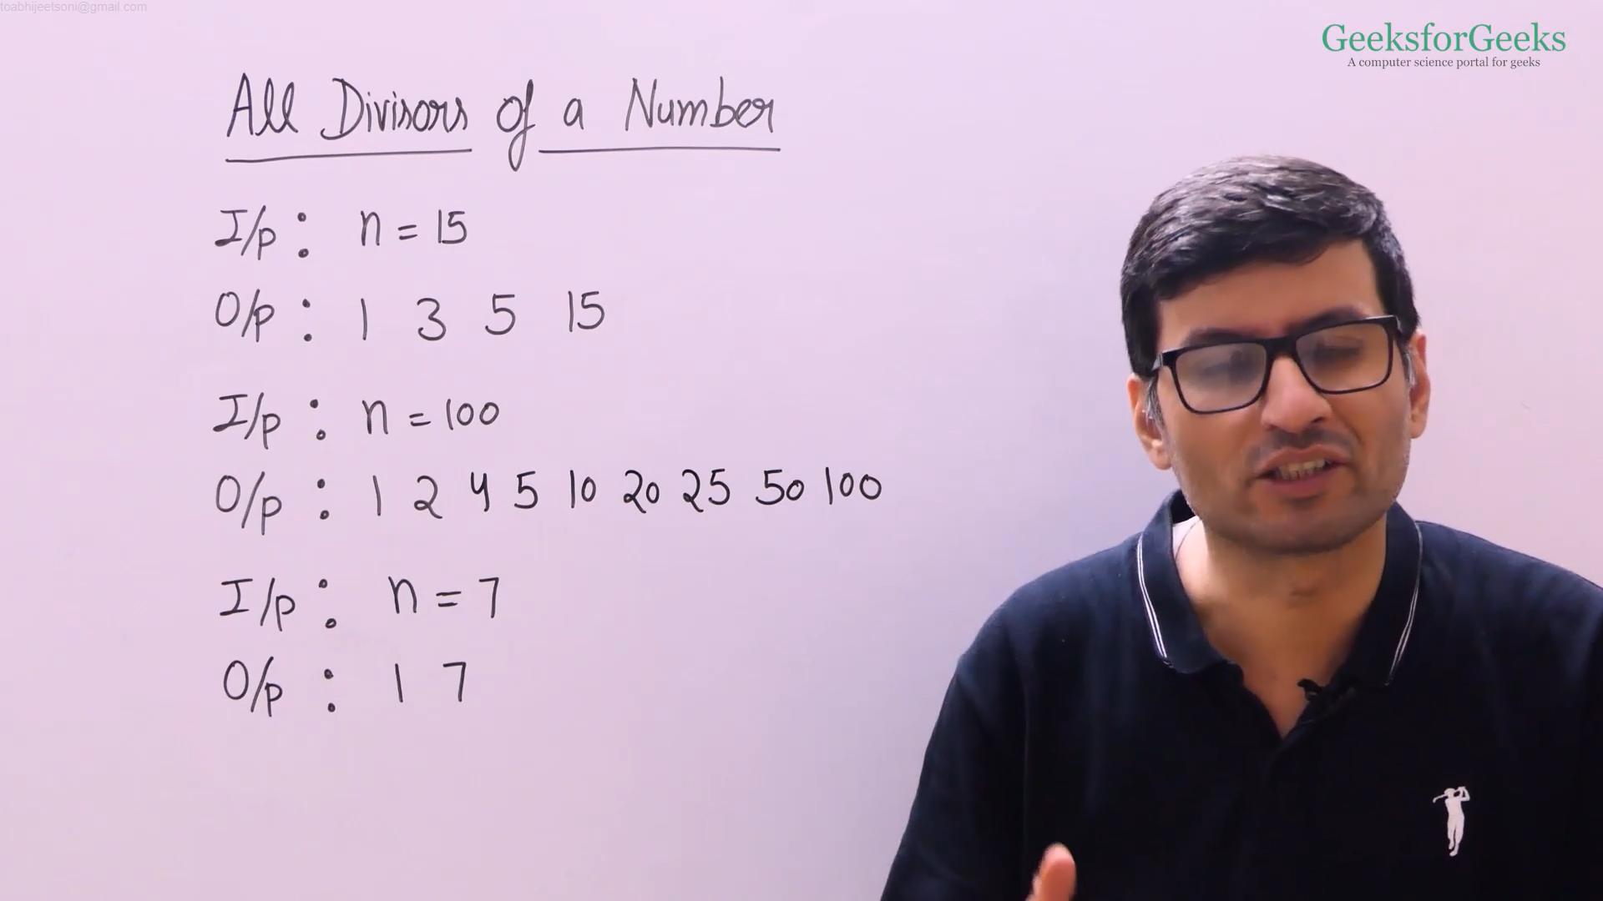

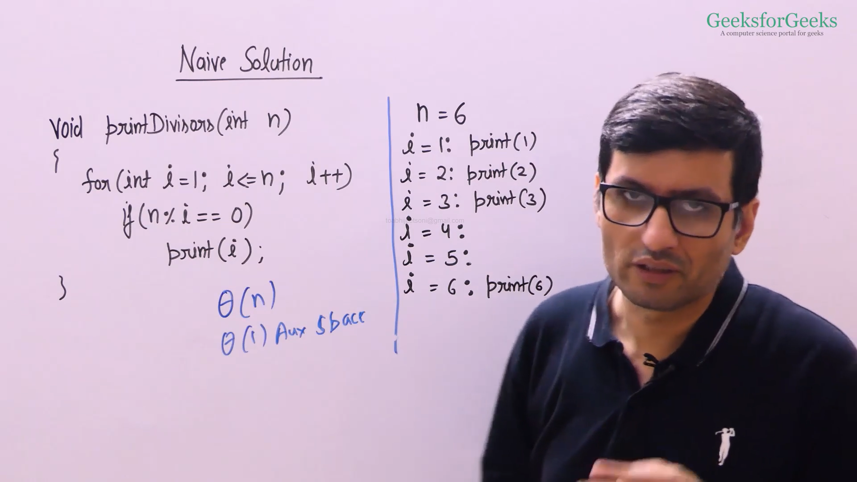

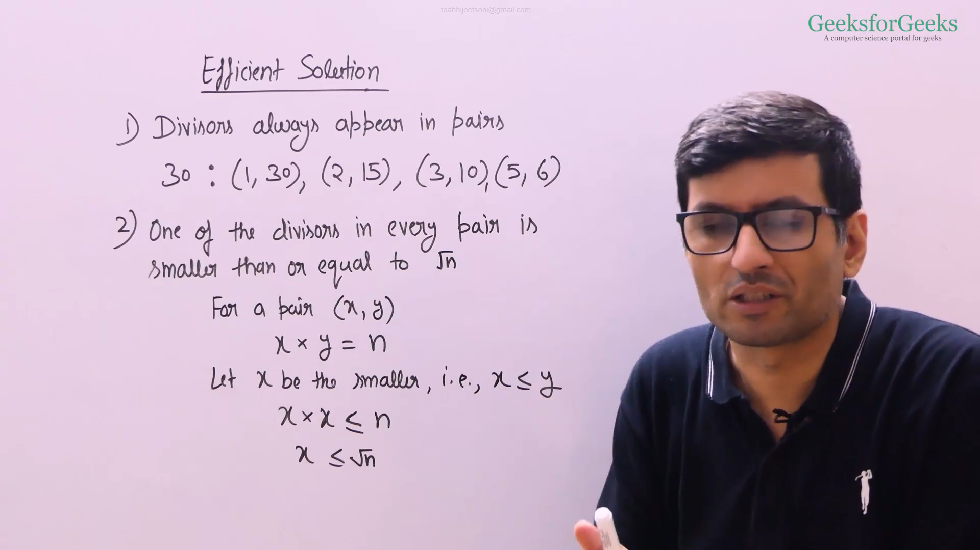

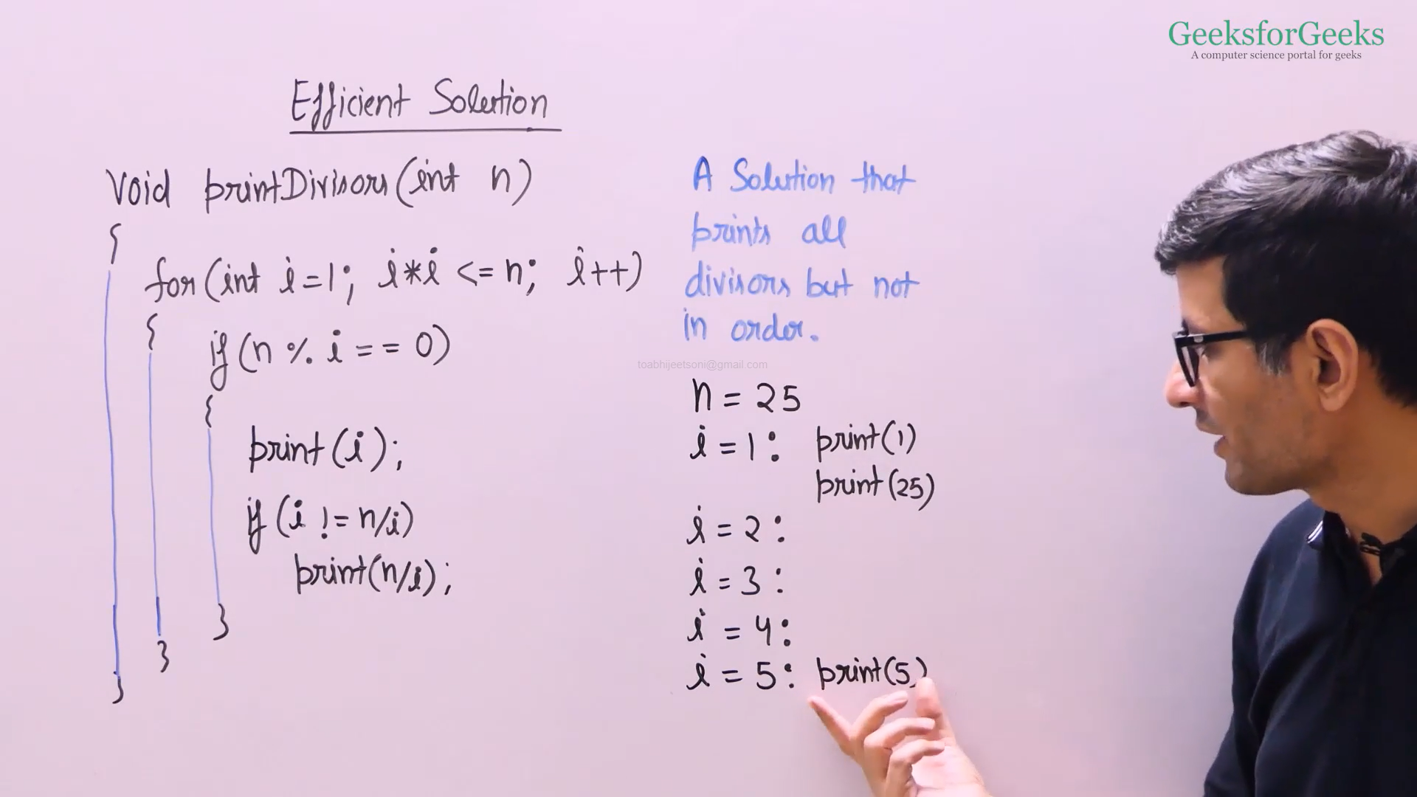

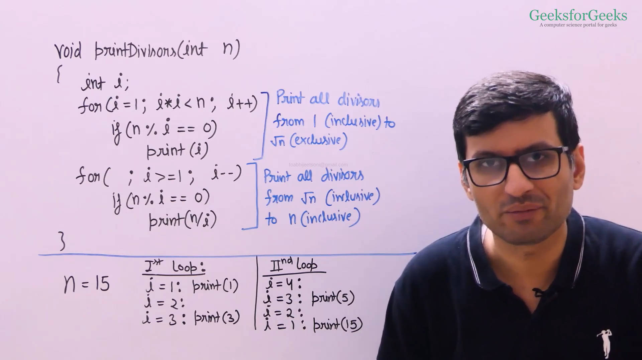

* Efficient Code with Sorted Order
  + CPP: <https://ide.geeksforgeeks.org/xd6XqmJVTC>
  + Java: <https://ide.geeksforgeeks.org/tySfcXuqt2>
* Efficient Code
  + CPP: <https://ide.geeksforgeeks.org/SEvGaRVguZ>
  + Java: <https://ide.geeksforgeeks.org/7GoVXAwXWk>

Sieve of Eratosthenes

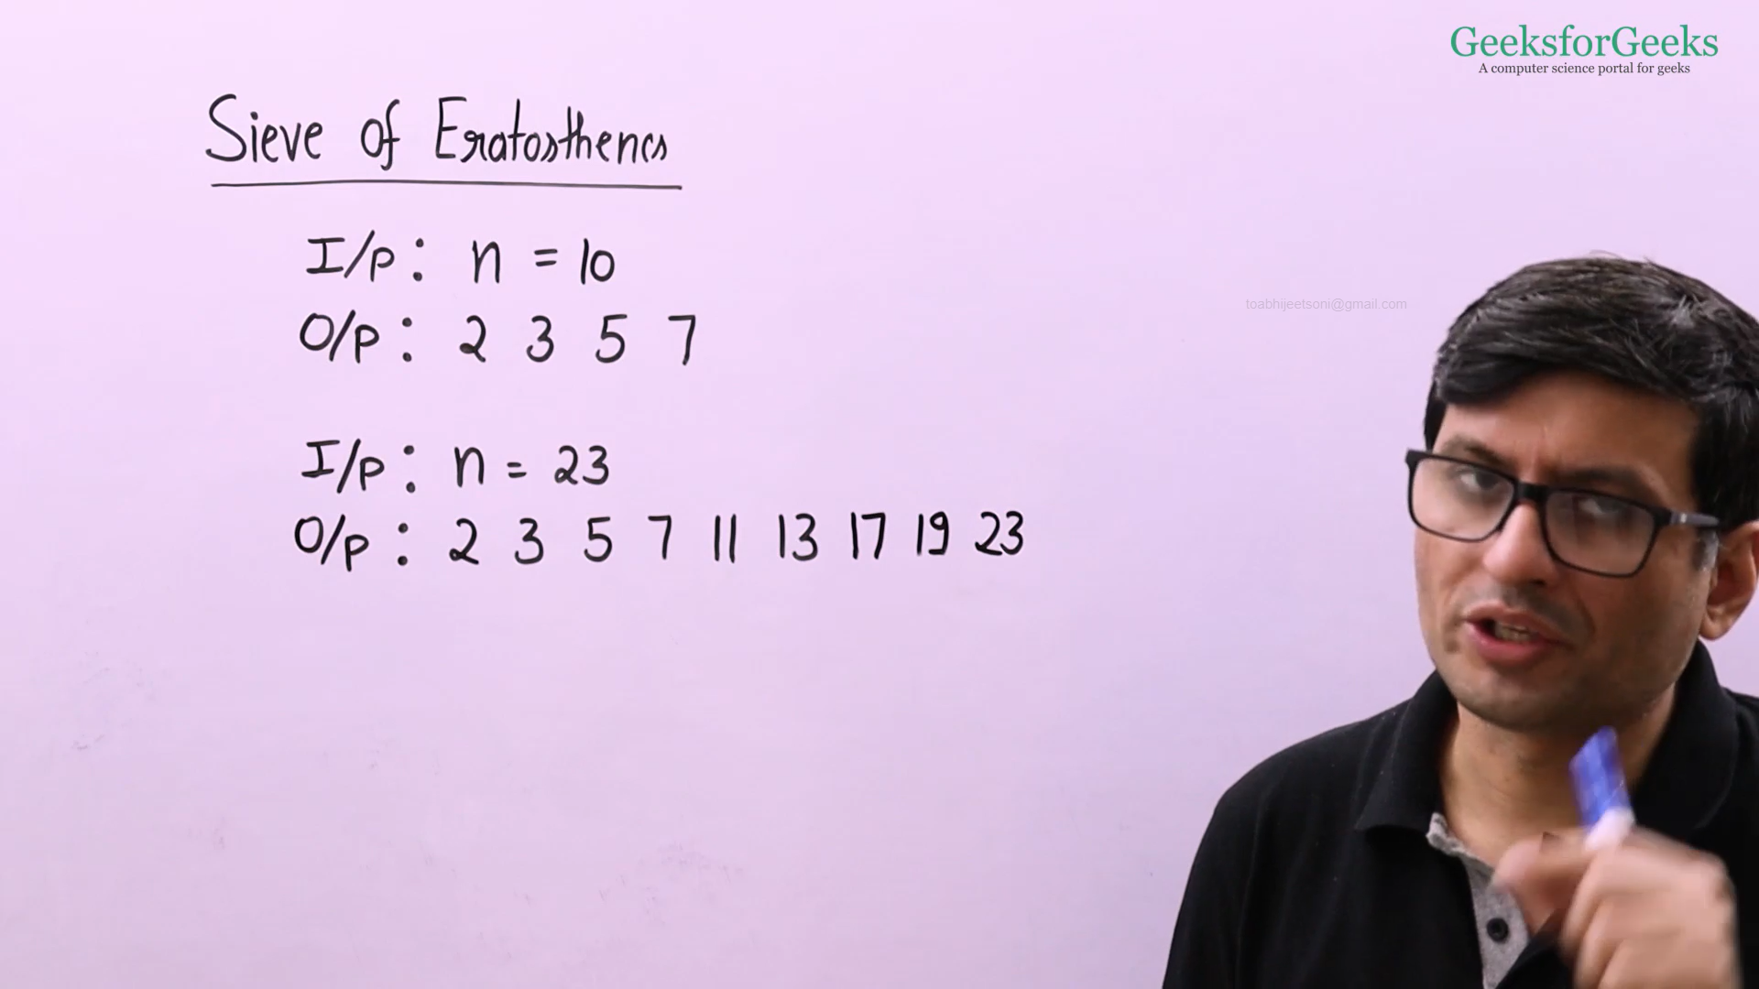

**Ref**: In [mathematics](https://en.wikipedia.org/wiki/Mathematics), the **sieve of Eratosthenes** is an ancient [algorithm](https://en.wikipedia.org/wiki/Algorithm) for finding all [prime numbers](https://en.wikipedia.org/wiki/Prime_number) up to any given limit.

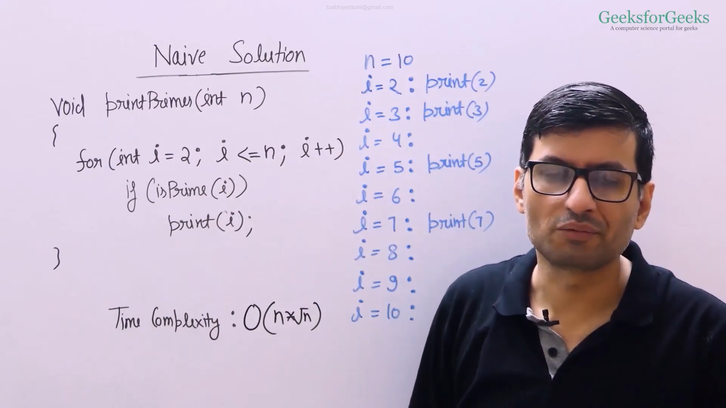

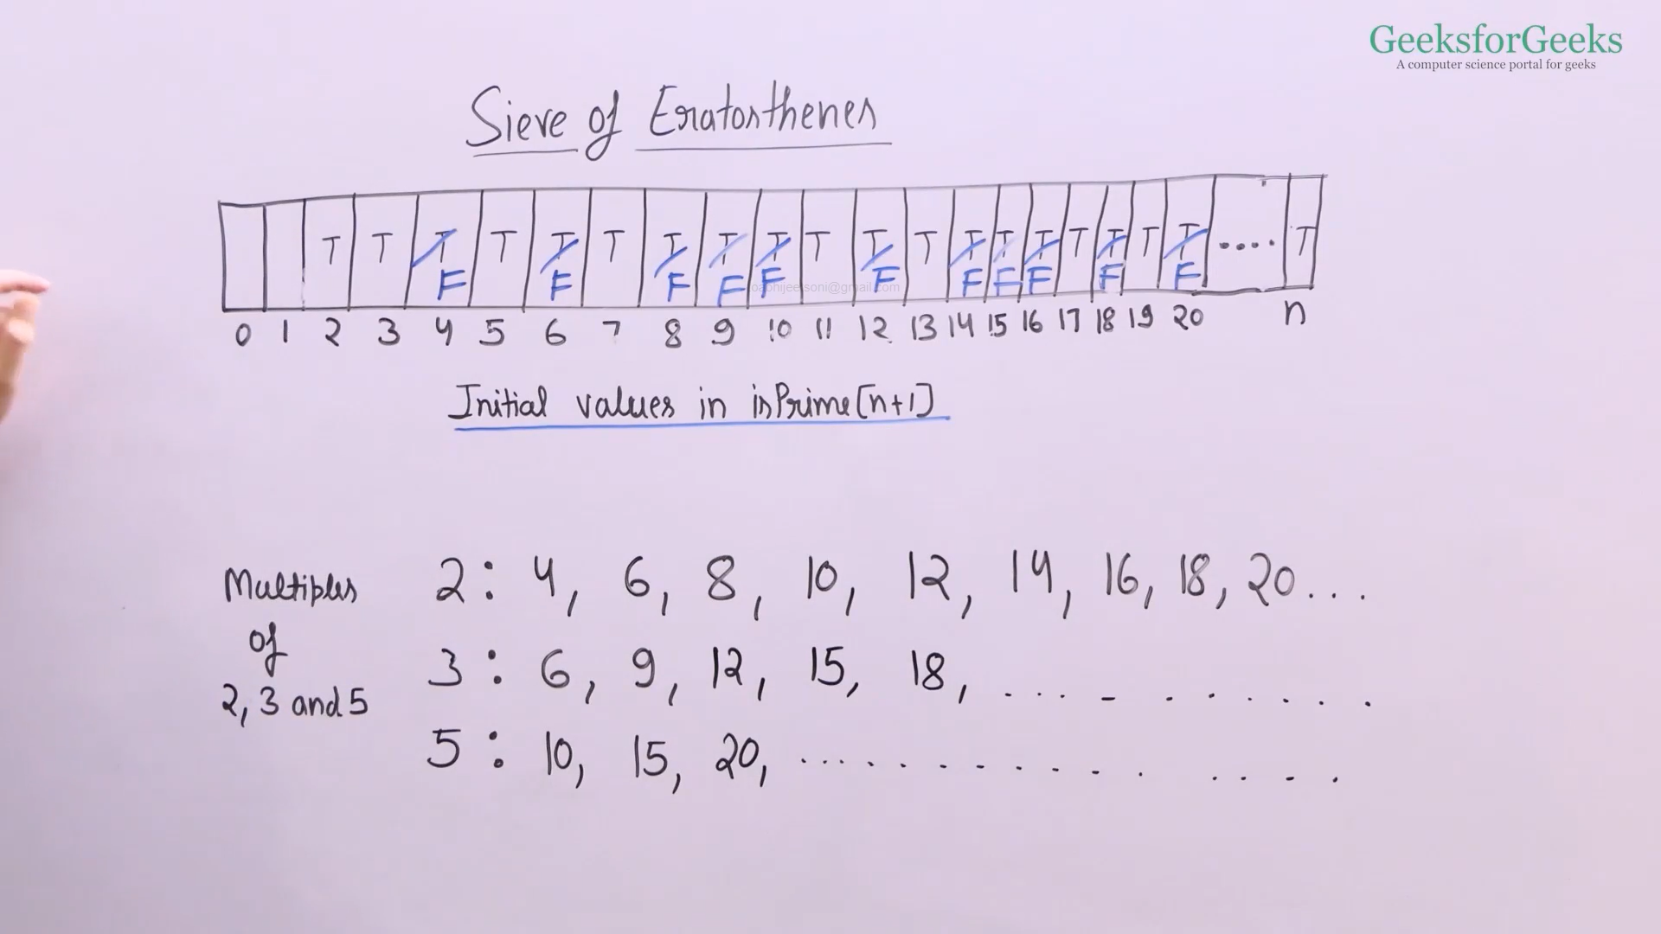

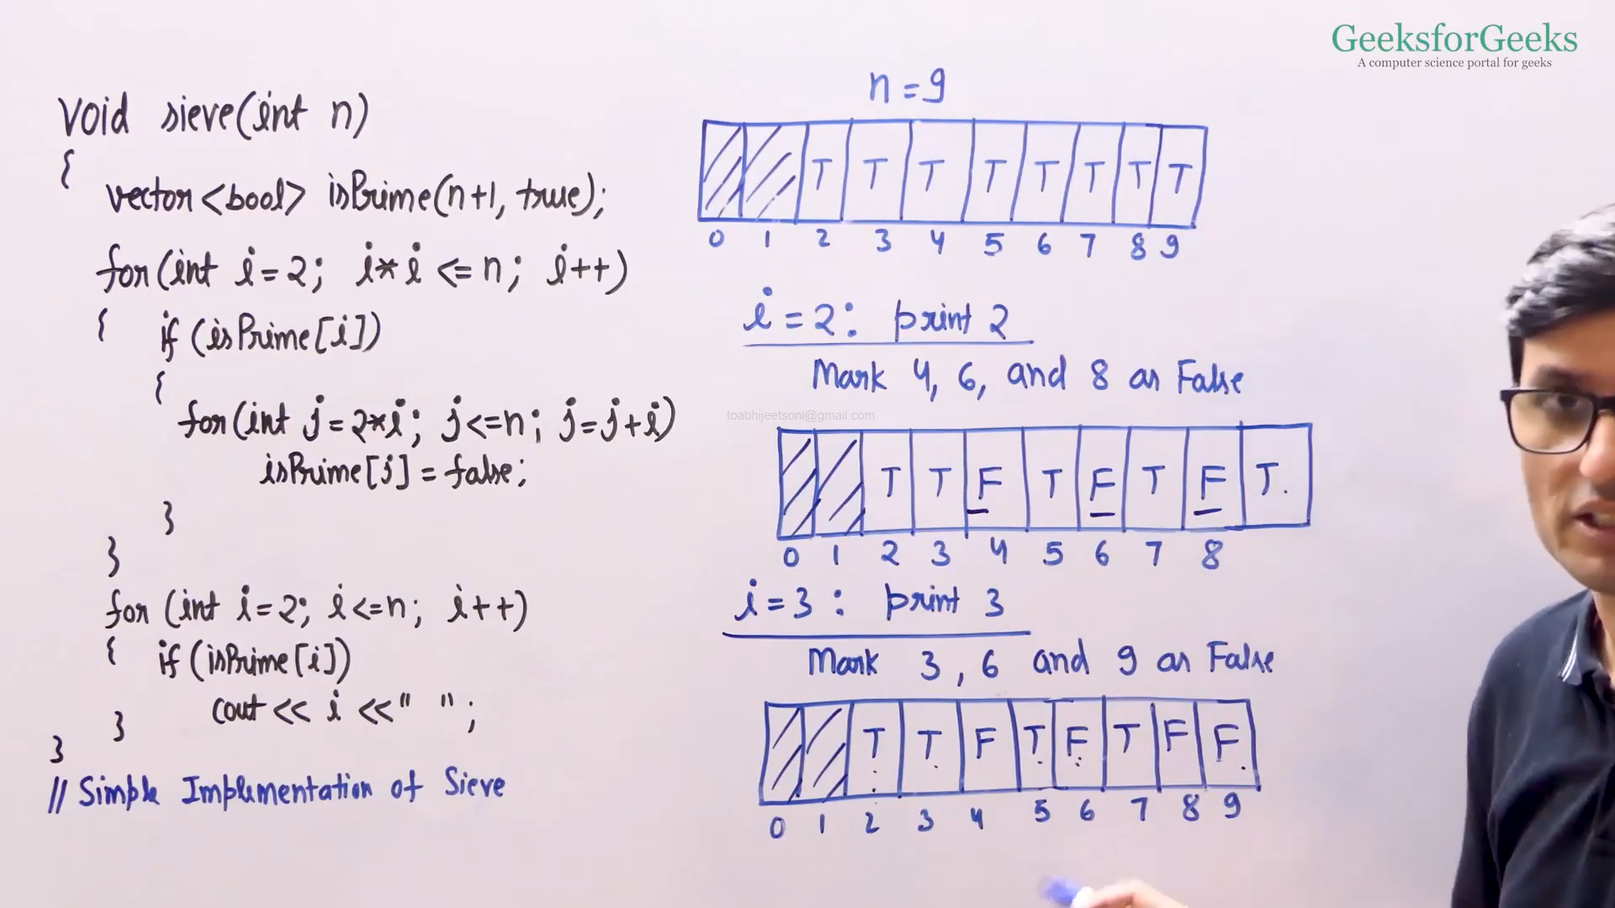

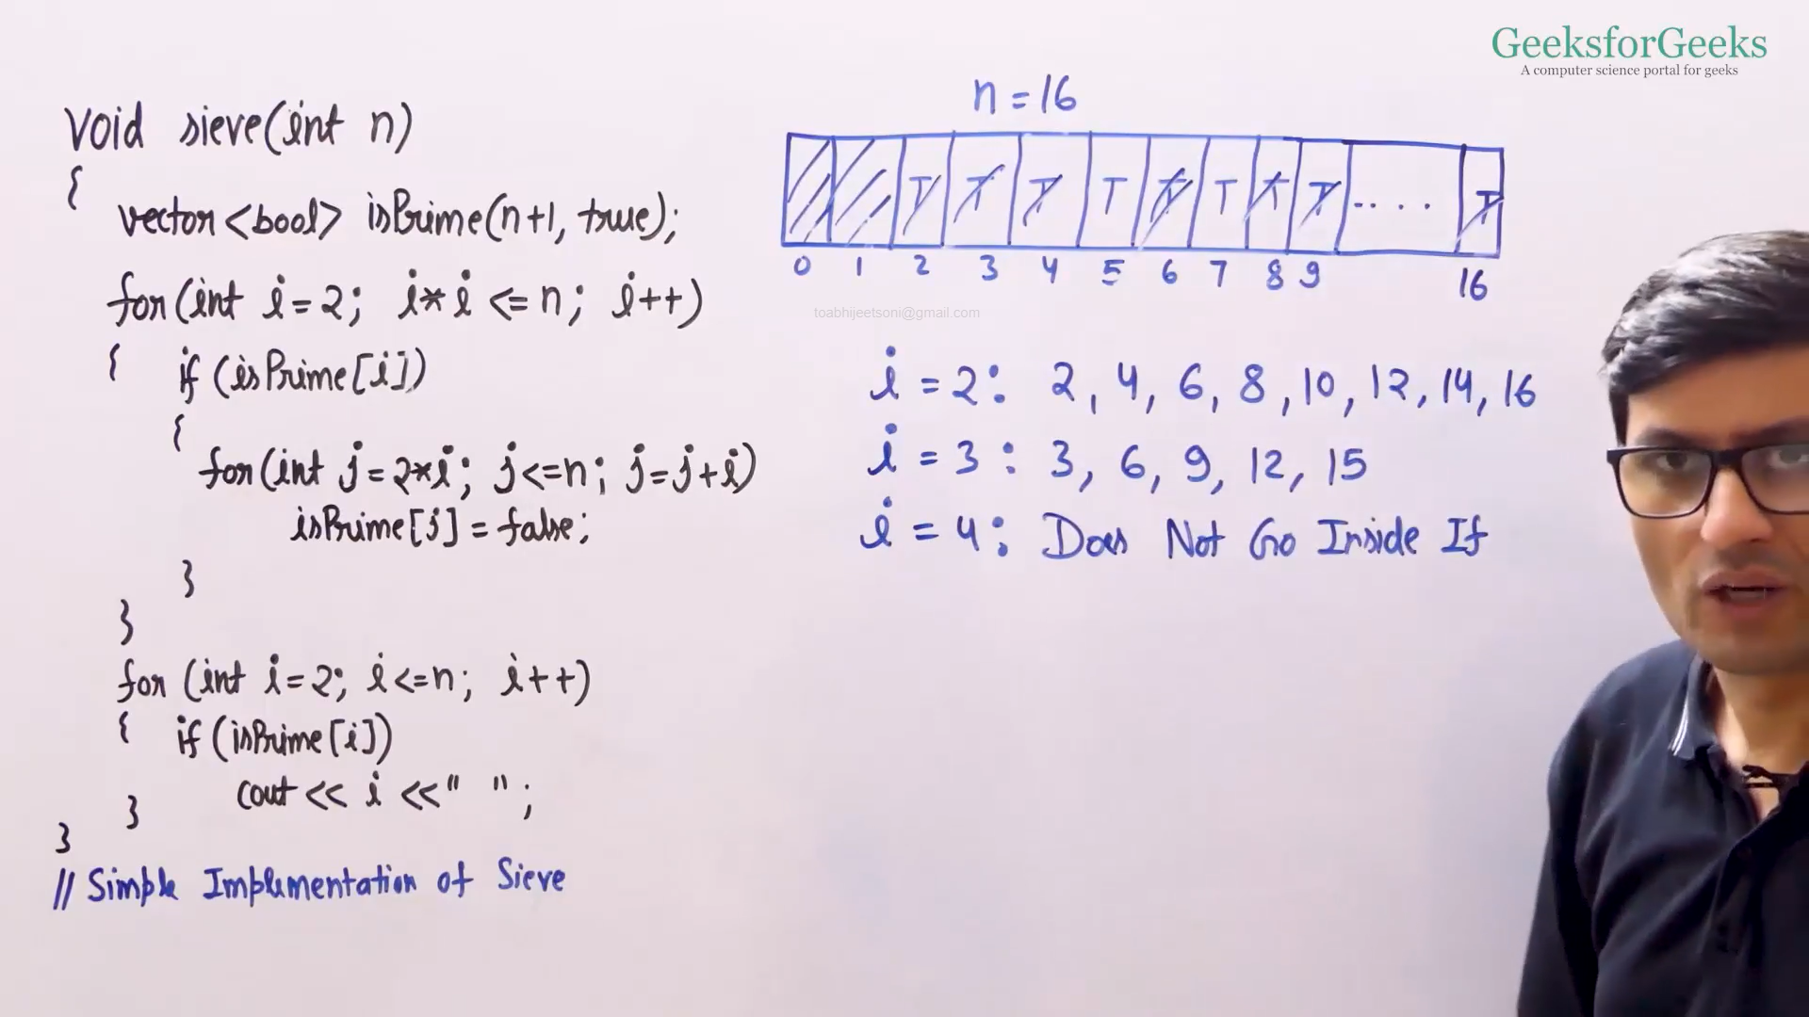

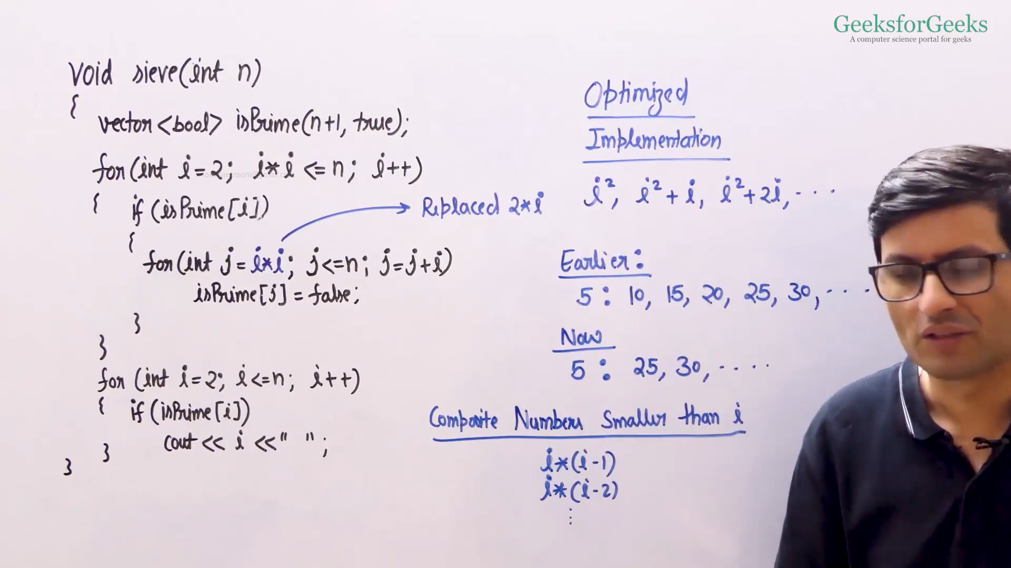

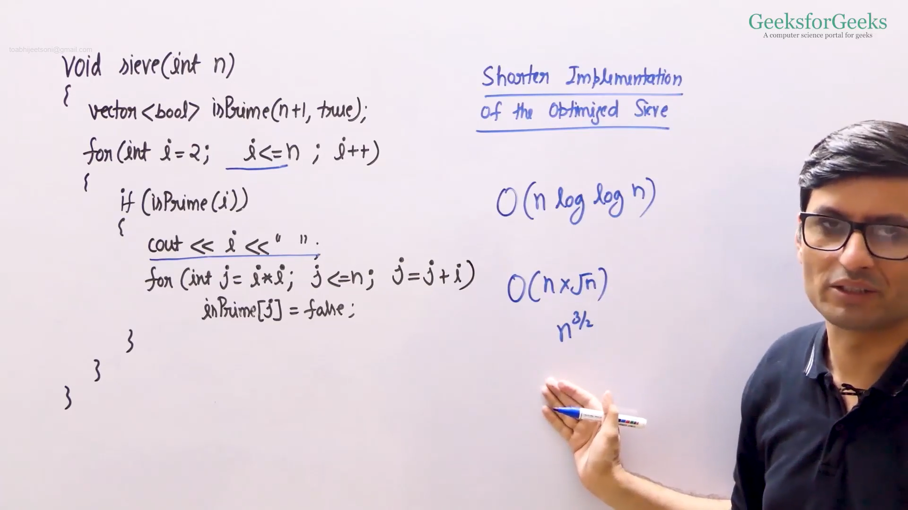

* CPP: <https://ide.geeksforgeeks.org/G6EaBjA3VD>
* Java: <https://ide.geeksforgeeks.org/QGIAxG9GFO>

Computing Power

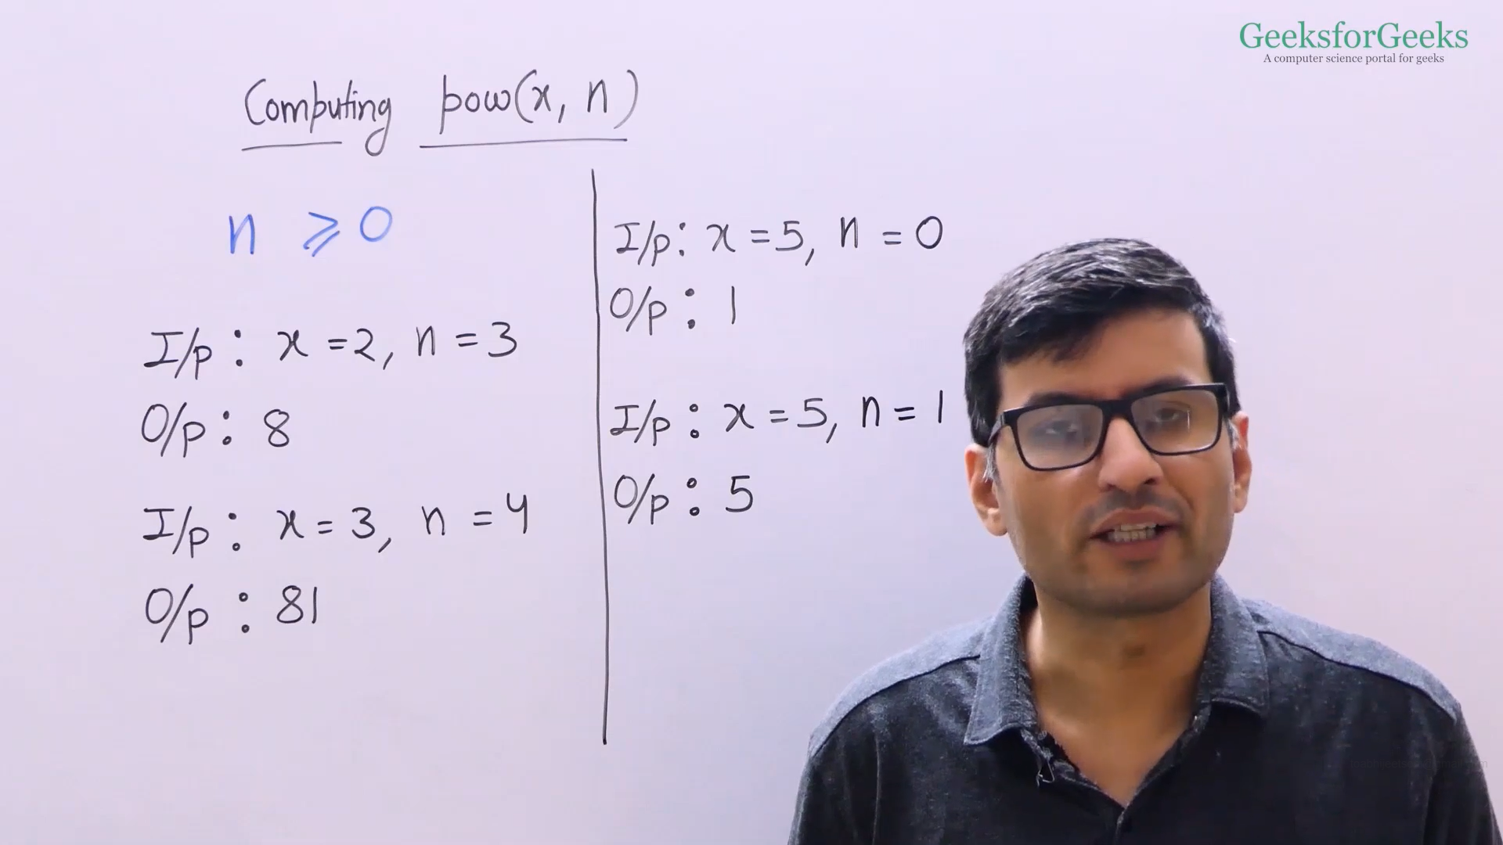

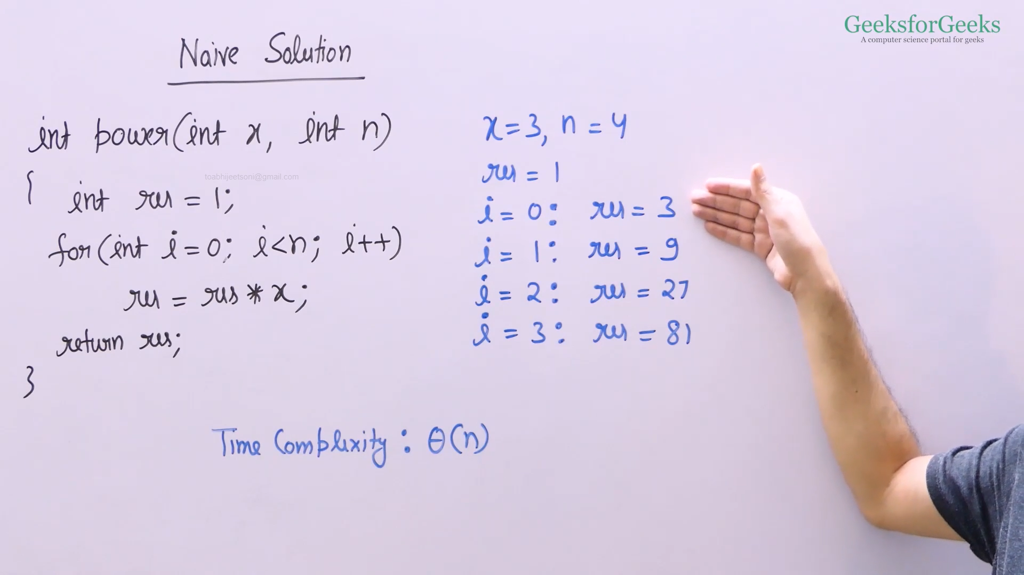

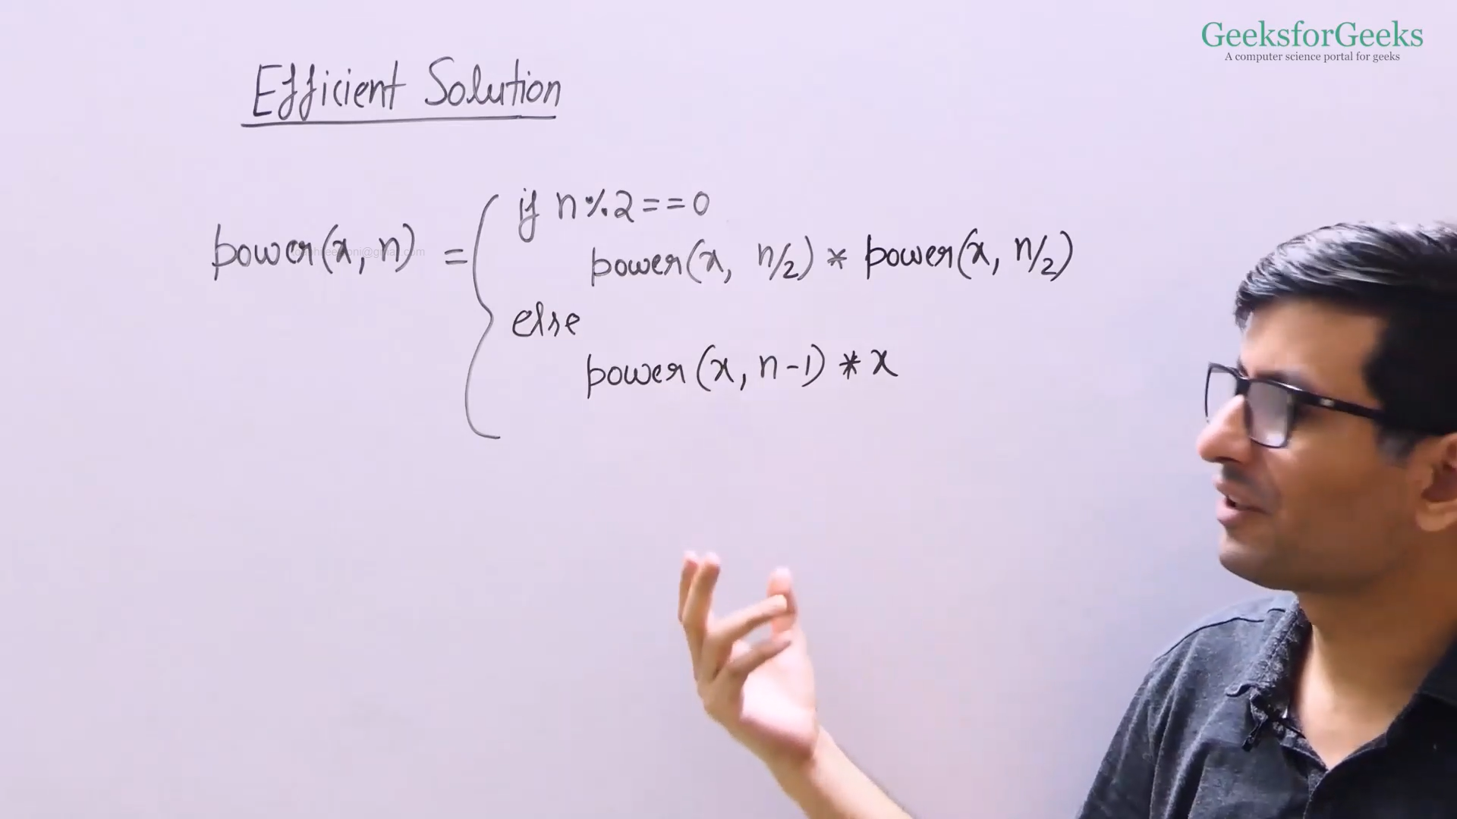

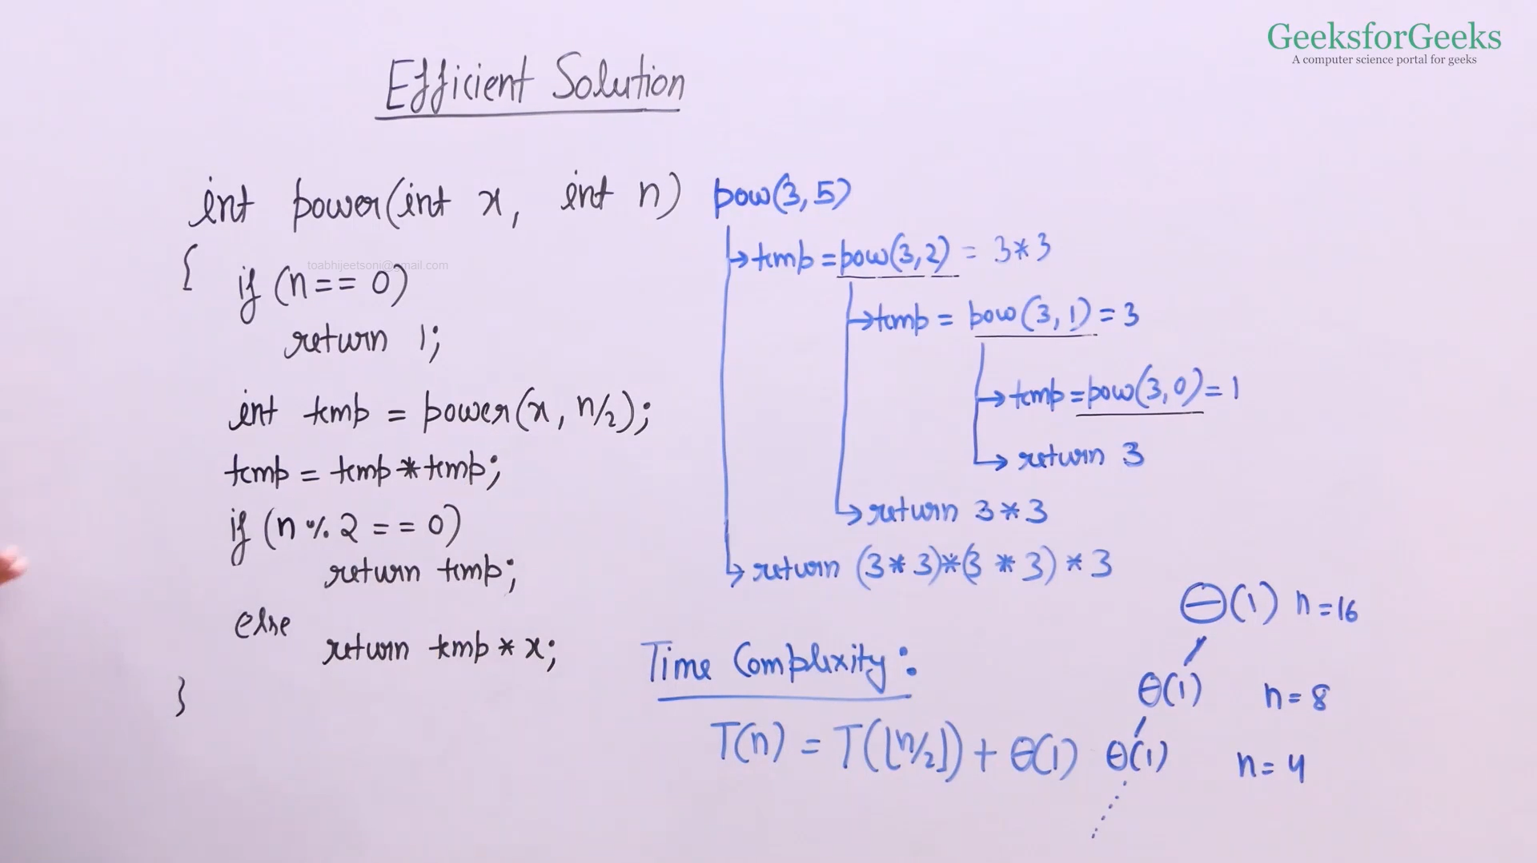

Time complexity = θ (log n) * c

= θ (log n)

Auxiliary space = θ (log n)

* CPP: <https://ide.geeksforgeeks.org/vhLhbMRd9d>  
  Java: <https://ide.geeksforgeeks.org/XouV5OsEWq>

Iterative Power

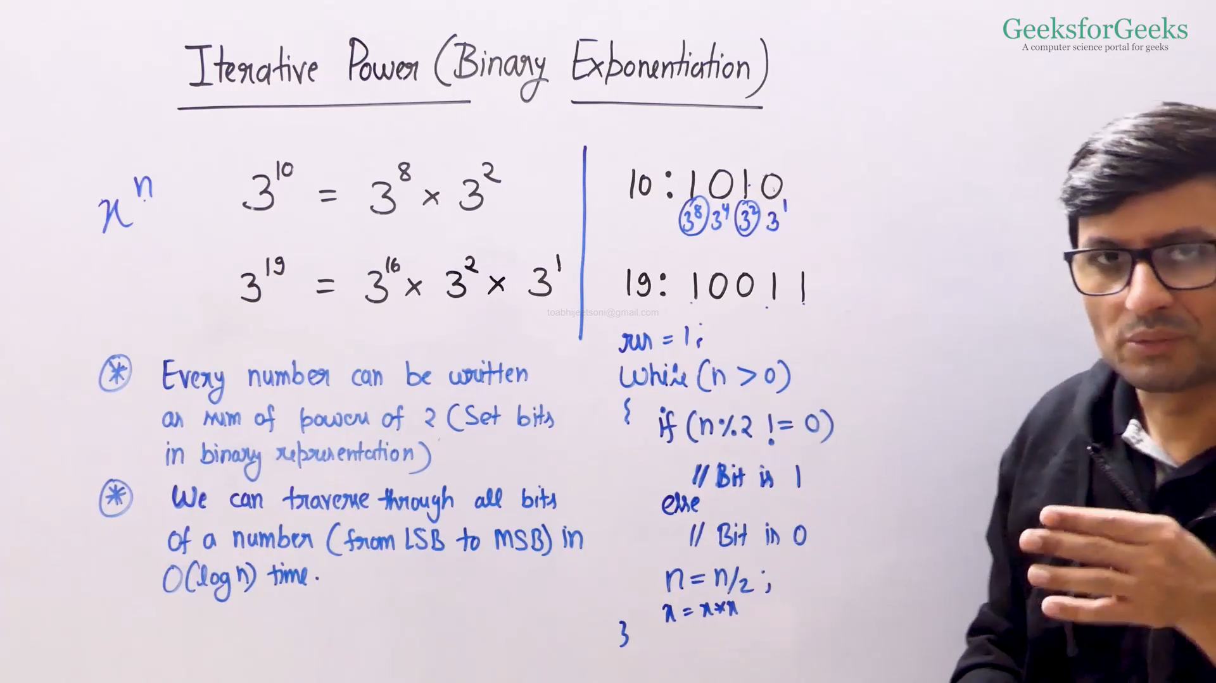

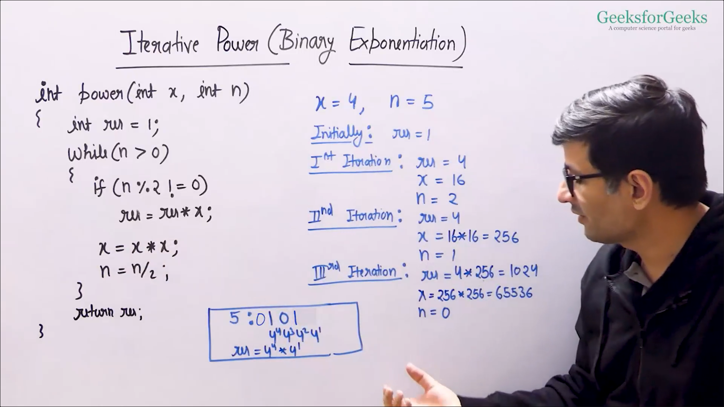

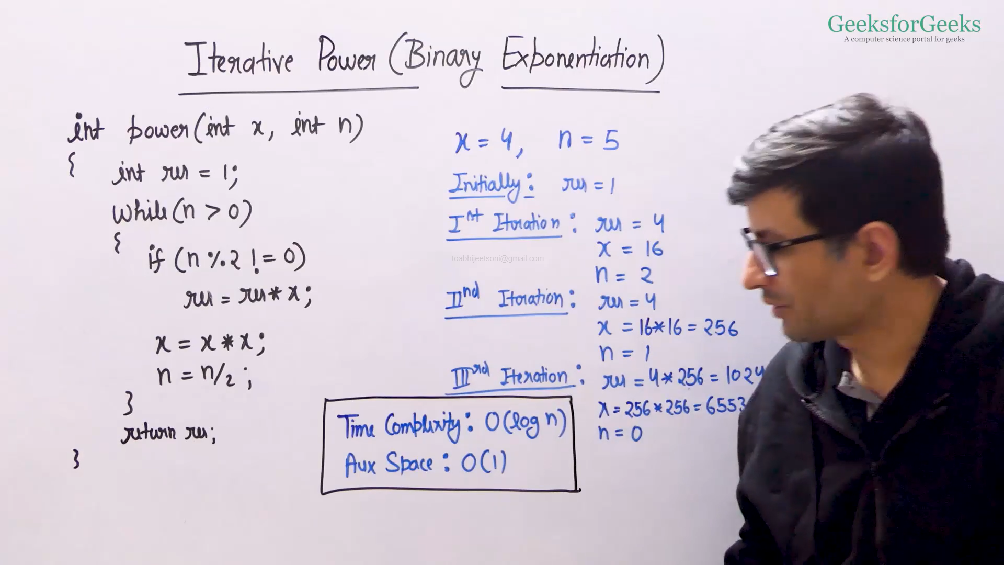

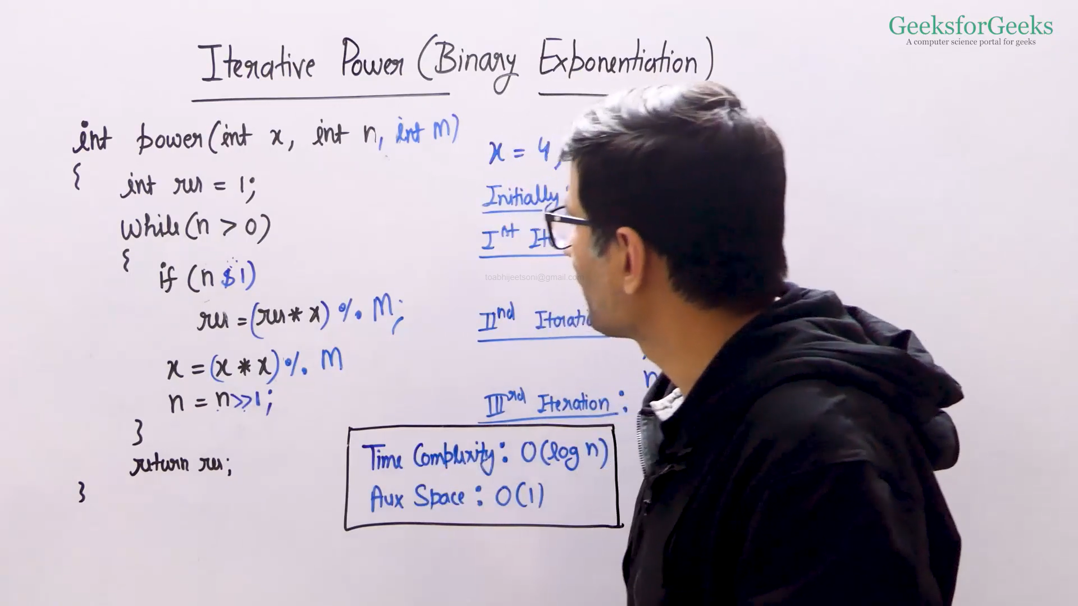

Note: This is applicable for C++, so please ignore this.

<https://www.geeksforgeeks.org/program-to-find-absolute-value-of-a-given-number/>

<https://www.geeksforgeeks.org/program-celsius-fahrenheit-conversion/>

<https://www.geeksforgeeks.org/program-to-find-the-roots-of-quadratic-equation/>

<https://www.geeksforgeeks.org/program-for-factorial-of-a-number/>

<https://www.geeksforgeeks.org/count-digits-factorial-set-1/>

<https://www.geeksforgeeks.org/find-nth-term-geometric-progression-series/>

<https://www.geeksforgeeks.org/prime-numbers/>

<https://www.geeksforgeeks.org/numbers-exactly-3-divisors/>

<https://www.geeksforgeeks.org/sum-of-two-numbers-modulo-m/>

Ref: <https://www.geeksforgeeks.org/modulo-1097-1000000007/>

<https://www.geeksforgeeks.org/multiply-large-integers-under-large-modulo/>

<https://www.geeksforgeeks.org/multiplicative-inverse-under-modulo-m/>